“The threat is the thing. The most important thing in motivating the members is the threat. Understanding the gravity of the threat is what produces action.”
--Kaye Robinson, former president of the National Rifle Association

After the Supreme Court issued its Janus v AFSCME decision on June 27, cries of calamity could be heard from unions all around the country, as if the sky were suddenly falling in. Union officers who never send out communications about union activities suddenly were on-line with predictions of doom and commitments to rebuild their unions. There was a sudden flurry of discussion, not just about the decision, but about the future of unionism in the US, and even on the impact of the decision on liberal political groups which are financially supported by union officers.
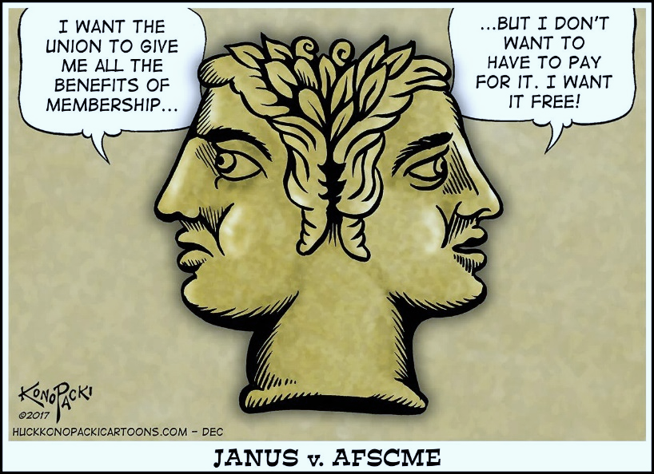
So what is the Janus decision and how serious are the consequences? If you have not followed the case, it was brought in behalf of Mark Janus, (or j.Anus) a child-support specialist, and two other workers in Illinois, who claimed that their First Amendment rights were violated when the state passed a law requiring payment of “fair share,” or “agency” fees. Workers covered by the union contract who did not want to join the union must pay in a sum of money—less than full union dues—to cover the cost of enforcing the contract and negotiating new ones.
Janus, a $71,000-per-year child support specialist at the Illinois Department of Healthcare and Family Services in Springfield, IL, was covered by an AFSCME contract, part of a unit of approximately 35,000 workers. Janus stated that he filed the law suit because he objected to the donation of $400,000 from AFSCME in 2014 to the Planned Parenthood Action Fund.
Other states had also passed “enabling legislation,” allowing unions to negotiate contract clauses that mandated payment of agency fees. The argument in favor of such a law is obvious: all of the workers covered by the contract negotiated by the union get the benefits, and the union may be required to represent every worker, so it is only fair that every worker contribute some money.
If workers chose to pay only the agency fee, they were not considered full members in good standing of the union. They could not attend union meetings or vote in union elections or on new contracts without special permission from the members and officers. Many unions have implemented special benefits plans, like Union Privilege, which are limited to full members.
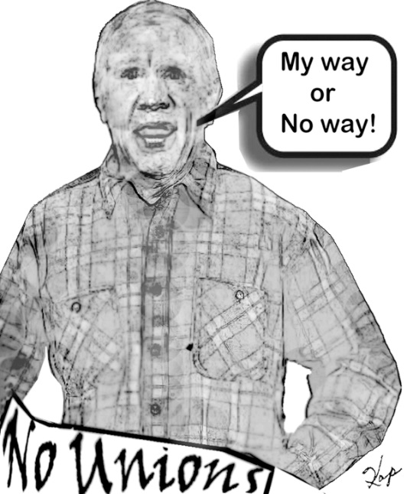
Bruce Rauner, a millionaire investment banker elected governor of Illinois in 2014, had built a whole campaign on anti-unionism. In his first State of the Union address in January, 2015, he announced that all “unfair share” money from 6,500 agency fee payers (out of a state workforce of 78,000) would be held in escrow by the state. By extending an Executive Order, Rauner bypassed the state legislature. He also stated that he “will encourage local governments to pass such right-to-work laws, referring to them as ‘employee empowerment zones,’ which permit workers to refuse to pay any fee to unions that, by federal law, are required to represent them if the union is the recognized bargaining agent in the workplace.”
After issuing his Executive Order, Rauner also filed a federal lawsuit to try to have the matter escalated to the U.S. Supreme Court. When a federal judge ruled that Rauner “had no injury or stake in the suit” and therefore had no standing to challenge the law in court, Mark Janus, with the financial support of a block of right-wing foundations like The National Right to Work Legal Defense Foundation (NRTWLDF), stepped up.
Speaking of “having no stake,” once the decision was issued, Janus took his payoff. Within two weeks, he quit his state job for a position with The Illinois Policy Institute and its affiliated Liberty Justice Center, so the decision could be called the Judas decision, even though The Institute claimed that Janus would be a “workers’ rights advocate.” “The Illinois Policy Institute and its affiliated Liberty Justice Center supplied Janus with the legal firepower to bring the case to the nation’s highest court. It resulted in their biggest policy win to date — and potentially bolstered their political influence.”

One union advocate posted this farewell: “Mark #Janus is retiring from the State of Illinois today, so we threw a retirement party in his building! Unfortunately it's for members only, so he isn't able to attend :( #unionstrong #afscme.

Rauner’s continued campaign to eliminate the agency fee clause, negotiated by his predecessor, Pat Quinn, is an example of why the whole Janus case is not just a legal issue, which union officers fought by picketing the Supreme Court, but is part of a comprehensive anti-union campaign that must be confronted with a strong nationwide union strategy.
While the 5-4 decision supposedly looked only at obscure legal issues—is it a violation of the Constitution to collect these fees? Can the Supreme Court reverse a previous decision?—the social policy and anti-union strategies reflected in the case are very important for every union member (and non-member), in both the public and private sectors.
As an appreciation for the anti-union strategy, this is the second case to get to the Supreme Court in which the First Amendment was used as a cover by an anti-union worker, with the financial support from right-wing money. Several years ago, the case Friedrichs v California Teachers Association used the same flimsy Constitutional argument but was blocked in January, 2016, by the death of Supreme Court Justice Antonin Scalia and the justices had a 4-4 decision in March, 2016. The success of the Trump administration in confirming Justice Neil Gorsuch in April, 2017, provided the decisive vote in this very important Janus decision.
The question is how serious are the consequences of this decision? Or of the election of Donald Trump, with support from almost half of union voters?
These attacks, designed to create dissension in every workplace and to reduce union membership, have unfortunately been successful. The direction of unionism in the US since the 1940’s has been downhill, and Janus is just another step in a direction that we must reverse—and quickly--because the US is becoming an open shop country.
Union membership in the private sector reached a peak of 37% in 1959, and union contracts set a pattern for all industries, creating “the middle class” in the US. In 2017, however, The Bureau of Labor Statistics showed union membership in the country in 2017 was 14.8 million, about the same number as in 1946. The percentage of private sector workers in a union was only 6.5%, about what we had in 1900. “The union membership rate of public-sector workers (34.4 percent) continued to be more than five times higher than that of private-sector workers (6.5 percent).” So public sector unions, and the laws which protect their revenues, are now Target # 1.
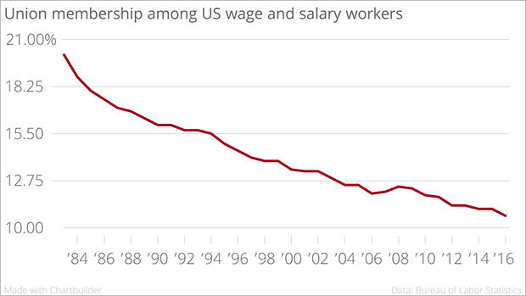
Hawaiʻi is the country’s second most-unionized state but even here, the direction has been significantly downward. “There were 129,000 union members last year in Hawaiʻi, according to the U.S. Bureau of Labor Statistics. That’s a little more than one out of every five workers — double the national average but down considerably from the state’s peak of 30 percent in 1989.”
A common mistake about Janus is the belief that somehow—just as we are all required to pay taxes— public employees were automatically forced to pay agency fees. In fact, one important point missing from a lot of this discussion is that only 22 states—less than half of the country—had laws that authorize agency fees.
Even within these states, there are more limitations. In Maryland, for example, only five counties—out of 23-- and the City of Baltimore had legislation permitting unions to try to negotiate an agency fee clause. The counties are the urban ones and since contracts are negotiated locally, the other jurisdictions were already open shop and were not directly affected by the Janus decision. The Maryland Teachers Association (MTA) which represents 74,000 teachers across the state, noted that there are 3,000 agency fee payers and about 18,000 non-members state-wide, so about 28% of teachers covered by an MTA contract are already free riders.
The former governor of the state, and 2016 presidential hopeful, Martin O’Malley supported legislation in 2011 to let unions for state workers negotiate an agency fee clause. At that time, one source reported “AFSCME represents 21,000 employees throughout state government, and about 8,500 of them are members of the union.”
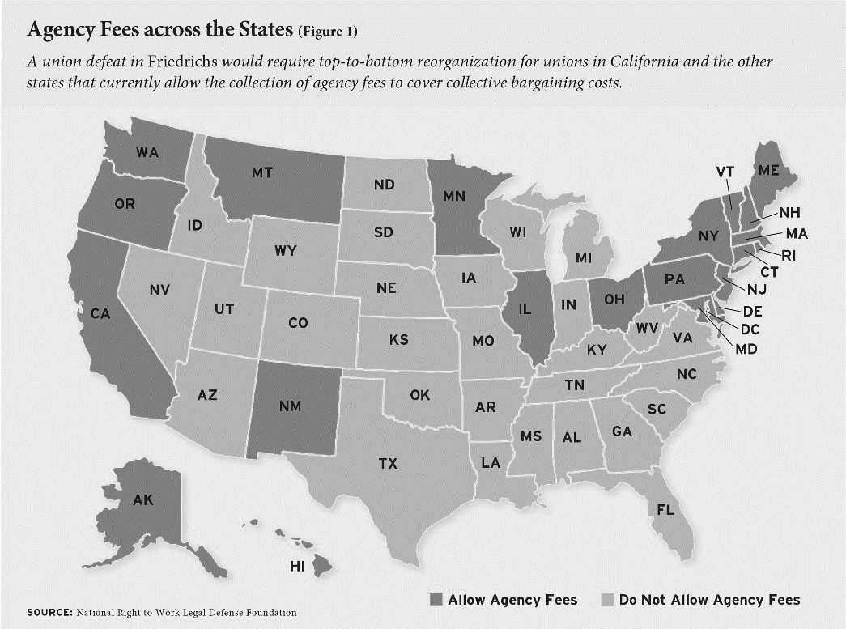
It is important to recognize that the Janus decision is limited to state and municipal public sector workers. Beyond these limits on negotiating agency fees for public workers are two enormous public sector open shops: the federal government and the US Postal System.
At the same time, the decision will, at least temporarily, have a disastrous impact on public sector unions. Announcing that the state of New York will no longer deduct agency fees, State Comptoller Tom Di Napoli estimated that there have been 31,000 state workers paying the service fee.
“The Illinois Economic Policy Institute, in a study released May 9, painted a dire picture for government worker unions if Janus prevails. In 2017, Illinois had 317,000 state and local government union members and would, with a Janus win, lose over a few years 49,000 members, the study estimated.”
The impact on public sector unions in Hawai’i is not clear because state Comptroller Roderick Becker said that the state’s payroll record does not distinguish between union members and agency fee payers. The office was “asking unions to confirm whether or not they have a non-member population and to provide the names of those members to the state. Once the names of nonmembers have been provided, agency fee withholdings will be suspended.”
“Public employee unions have big memberships and play a prominent role in Hawaiʻi’s economy and politics. The Hawaii Government Employees Association, which represents a number of government employees, has 42,000 members. The United Public Workers union has 14,300. . . . The Hawaii State Teachers Association, the state’s fourth-largest union, has a 99 percent rate of membership, counting 13,700 individuals, according to president Corey Rosenlee. Slightly more than 100 Department of Education teachers are not members. . . . Could Hawaiʻi defy the economic theory? Richard Rand, a Hawaiʻi labor lawyer, said Hawaiʻi workers are less likely to quit paying dues because of the role unions have played in the state’s history and culture. ‘I don’t think the sky is falling as much as some in the media are saying,’ Rand said. The teachers union agrees. ‘What we’re going to do is, we’re planning to have lots of conversation,’ Rosenlee said. ‘We have hundreds of teachers who have been trained on how to talk to our members.’”
For a few people who think the Janus decision is about the US Constitution, or about obscure legal principles like stare decisis, the full decision is clearly a social statement about the power of workers to organize and the ability of employers to enforce obedience—“labor peace”—on unionized workers.
The previous Supreme Court decision on agency fee payments was Abood v Detroit Bd of Education (1977), and the decision was in favor of allowing agency fee payments, a decision even supported by Justice Lewis Powell, whose infamous Powell Memorandum (1971) laid out a strategy to eliminate unionism. A significant consideration in this decision was “labor peace”—as if public sector unions whose officers would have to struggle to collect dues might be more aggressive. The decision also endorsed exclusive representation, concerned about the “chaos” that might develop if “competing unions” were in the same workplace. Over the past 41 years, the Justices, and their political handlers, have obviously seen “labor peace” become such a way of life that it no longer needs to be politically supported.
From a historical perspective, it is important to know that the Abood case was supported by The National Right to Work Legal Defense Fund (NRWLDF). “With Abood, the NRWLDF argued that it was a violation of public-sector workers’ First Amendment rights to require them to pay any union dues. It was a massive case, with some 600 plaintiffs (unlike more recent cases, like Janus, which have involved a few dissident workers). However, more than half of those represented in the suit would turn out to be deceased, retired, or otherwise not in the bargaining unit, while a majority of those workers who were in the bargaining unit voluntarily chose to remain members of the union, according to an appellant brief filed to the Supreme Court in the Abood case.”
The next legal attack on agency fee legislation, using bogus arguments about the US Constitution, came in June, 2014, with a Supreme Court decision called Harris v. Quinn, also involving Pat Quinn, the Illinois governor before Rauner. Funded again by NRWLDF, the case covered home health care workers for Illinois's Home Services Program, who were paid by federal Medicaid funding to work as a "personal assistant" to people who needed care, so both the patient and the state were considered “employers.”
The decision, again written by Justice Samuel Alito, stated that the workers were hired by the patients and could not be charged agency fee payments by SEIU, the union that represented them. In an evaluation that now seems prophetic, an Op Ed in The New York Times stated: “a 5-to-4 majority of the Supreme Court fired its own salvo in the war on unions. Though its decision in Harris v. Quinn was narrow, saying that, in some cases, unions could not collect fees from one particular class of public employees who did not want to join, its language suggests that this may be the court’s first step toward nationalizing the ‘right to work’ gospel by embedding it in constitutional law. . . . Unions are already reeling. At a time when workers are losing economic ground, we should be looking for ways to strengthen their ability to join with co-workers and bargain collectively to improve their lot. Instead, the court in Harris sided with those who seek to weaken it further.”
For the 5-4 majority in the Janus decision, Justice Alito wrote this outrageous statement: “Designating a union as the employees’ exclusive representative substantially restricts the rights of individual employees.” (p. 2) Alito then expanded his attack: “First, agency fees cannot be upheld on the ground that they promote an interest in ‘labor peace.’ The Abood Court’s fears of conflict and disruption if employees were represented by more than one union have proved to be unfounded: Exclusive representation of all the employees in a unit and the exaction of agency fees are not inextricably linked. To the contrary, in the Federal Government and the 28 States with laws prohibiting agency fees, millions of public employees are represented by unions that effectively serve as the exclusive representatives of all the employees. Whatever may have been the case 41 years ago when Abood was decided, it is thus now undeniable that ‘labor peace’ can readily be achieved through less restrictive means than the assessment of agency fees.” (p. 2).
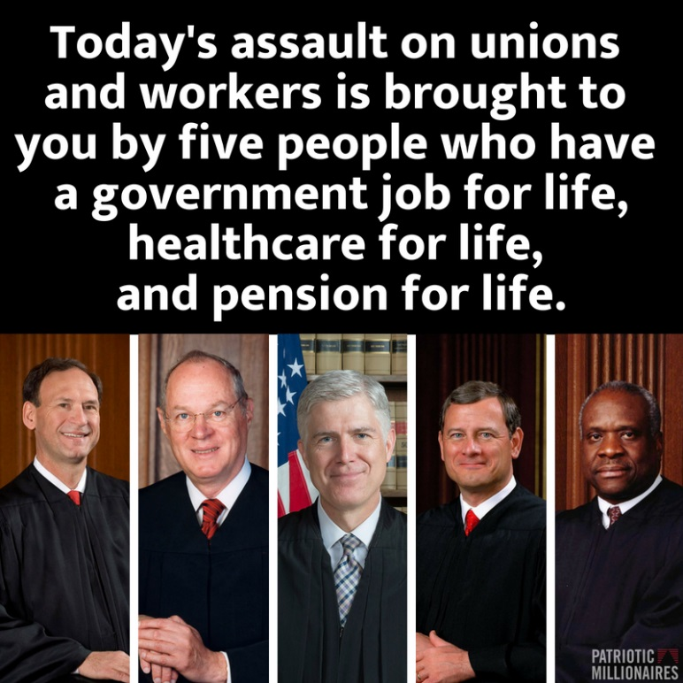
“But we must weigh these disadvantages against the considerable windfall that unions have received under Abood for the past 41 years. It is hard to estimate how many billions of dollars have been taken from nonmembers and transferred to public-sector unions in violation.” (p. 47)
To her credit, in a dissenting opinion in the Janus case, Justice Elena Kagan wrote: “Its decision will have large-scale consequences. Public employee unions will lose a secure source of financial support. State and local governments that thought fair-share provisions furthered their interests will need to find new ways of managing their workforces. Across the country, the relationships of public employees and employers will alter in both predictable and wholly unexpected ways. . . . There is no sugarcoating today's opinion. The majority overthrows a decision entrenched in this Nation's law – and its economic life – for over 40 years. As a result, it prevents the American people, acting through their state and local officials, from making important choices about workplace governance. And it does so by weaponizing the First Amendment, in a way that unleashes judges, now and in the future, to intervene in economic and regulatory policy."” (Dissent- p.2)
The future will determine whether they are correct.
The legal attacks on unionism are relentless. One case proceeding through the courts involves a California public school teacher (not Rebecca Friedrichs) named Robin Yohn, who claims that the “opt-out” procedures of the California Teachers Union is a violation of the First Amendment rights.
“Yohn’s case raises a second issue, one that will likely still be on the table even if the Supreme Court sides with Janus and overturns mandatory dues, as it’s expected to do. The California teachers argue that the current opt-out process for those who don’t want to pay dues is overly burdensome and also violates the Constitution. Instead, they maintain, educators who want to join should have to affirmatively opt into the union. Teachers who don’t know about, or can’t follow, the opt-out process are also being forced to subsidize speech they don’t support, said Terry Pell, president of the Center for Individual Rights, which brought Yohn’s case. The libertarian nonprofit law firm also represented California teacher Rebecca Friedrichs in her 2016 case challenging union dues. ’The opt-in/opt-out issue is just as much a First Amendment issue as the compulsory dues issue,’ he said. ‘They both go to unconstitutional burdens that the state is putting on speech.’”
In anticipation, of a favorable decision in the Janus case, in March, 2018, “lawyers representing government workers in Washington State asked a federal court to order one of the state’s largest public-employee unions ‘to disgorge and refund’ fees that nonmembers had already paid. Similar lawsuits were filed in California, New Jersey, New York, Pennsylvania, Minnesota and Ohio. The complaints could upend the legal system by arguing that states and private parties like unions face liability even though they followed the law as it existed at the time. They could also cost unions hundreds of millions of dollars.” Supported by the Freedom Foundation out of Evergreen, WA, the lead lawyer in the case was Jonathan F. Mitchell, nominated by President Trump to head “the Administrative Conference of the United States, a small federal agency that advises the government on improving its inner workings.”
This demand for refunds was partially, and dangerously, successful in Oregon, where SEIU Local 503, representing 72,000 members who work in state, local government, nonprofit agencies and higher education, agreed to refund almost $3,000 to Debora Nearman, who works as a systems analyst with the state Department of Fish and Wildlife. Nearman is a member of a statewide bargaining unit represented by SEIU but doesn't belong to the union.
Supported by the NRTWLDF, Nearman sued the SEIU for violation of her First Amendment rights by opposing “her political and religious views and even led a campaign against her husband, Mike, when he successfully ran as a Republican candidate for the state Legislature in 2016.”
“The fact that SEIU spent $53,260 to oppose Mike Nearman's candidacy by campaigning against him and distributing fliers that disparaged him ‘is a vivid example of why people frequently don't want to fund a labor union,’" said Patrick Semmens, a vice-president of the NRTWLDF.
The ominous news is that the NRTWLDF is handling some 200 other cases across the country, including a class-action lawsuit in California by 30,000 state employees. If the U.S. 9th Circuit Court of Appeals rules in favor of the plaintiffs in the California case, they stand to be refunded more than $100 million, Semmens estimated.
Before the Janus decision, and as another illustration of the shrewd thinking in the anti-union movement, a diabolical strategy was developed by Governor Paul LePage of Maine—divide and conquer-- to effectively split the membership of the two largest state unions, eventually persuading the members to “voluntarily” give up the agency fee clauses in their contracts.
As a kind of role model for Donald Trump, LePage has been described by various observers as “a crude buffoon,” “the most ignorant, angry, racist, and buffoonish leader in America,” and as “a terrible governor, a worse person, and he says something dumb nearly every single week. He’s a never-ending source of stupidity.” He told the Portland NAACP to “kiss my ass” when the civil rights group invited him to speak soon after his election in 2010 and demanded the removal of murals depicting Francis Perkins, the famous Secretary of Labor who had family roots in Maine. “The mural “sends a message that we’re one-sided, and I don’t want to send that message,” said LePage.
LePage proclaimed his support for open shop legislation after his election in 2010 but was unable to get it passed in 2013. In 2015, the legislature once again voted against making Maine the 29th open shop state.
In the 2017 negotiations, LePage’s administration proposed a choice to the Maine State Employees Association, Local 1989, with about 9,000 members, and to the AFSCME Council, with 900 corrections and mental health workers: get a two-year contract with 6 percent raises and eliminate agency fee clauses or keep the clauses and get a 1 percent raise. “MSEA-SEIU Local 1989 contract negotiators accepted the change in support of the pay increase in August, but negotiators for AFSCME rejected the proposal, recommending instead accepting only a 1 percent raise. But the 900 or so members of AFSCME rejected the negotiators’ contract and voted to ratify LePage’s offer, giving them the 6 percent wage increase while eliminating the mandatory fees for nonunion members.” While the president of the SEIU council proclaimed that “the union has “emerged stronger and more united” as a result,” LePage clearly outorganized the officers of both unions.
The issue predictably raised on social media the discussion of the value of unions, with comments on the news article running from
- “As a dues-paying member of MSEA Local 1989, headline should be revised to read: ‘State workers get greedy and lose sight of the bigger picture’” to
- “Umhuh. Lets see...’feed the family’ or ‘feed the union’. Workers chose their families. Correct choice” and
- “It's nice to see the Forced Unionism fees will no longer be required as a condition for those folks to keep their jobs” and
- “MSEA Local 1989 Union leadership - six figure salaries. Yikes. The salaried union organizers make more than who they represent. I'm sure they want mandatory dues so THEY get a paycheck” and ““Free riders? I'm not a free rider, I DON'T WANT A RIDE!! I can take care of myself thank you. If I don't do my job well, I will be fired, as it should be. I don't need a Union FORCING me to pay them for NOTHING! Jeez dude, you don't get it do you? The union makes nothing possible for me, I'm not a sheep” and finally,
- “Now, every single state employee should join the union. Remember as Labor Day approaches the 8 hour work day, the 40 hour work week, child labor laws, overtime pay, minimum wage, call-back rules, hazardous duty pay...you enjoy all because union workers fought and died for your rights.”
“Ramona Welton, the president of MSEA-SEIU Local 1989, said the concessions on mandatory fees were necessary to get better wages for workers,” and claimed “she believed the union has “emerged stronger and more united” but the Director of MSEA, Rod Hiltz, resigned, explaining that 7 staff reps (approximately ¼ of total staff) were slated to be laid off, but with his resignation and resultant salary savings, there would be fewer losing their jobs.
Complicating the situation even more was a report from a Maine staff rep that “during negotiations two years before, LePage made the same offer. The negotiating team, made of reps from each of the 4 units, voted not to inform the members of that offer so 3 units voted to accept the alternate offer of 1% per year, unaware of the 3% per year with loss of fair share offer. However, 1 unit, Operations & Maintenance, learned of the 3%...offer & so the members voted to reject the 1%. . . offer.”
* * * * * * * * * * * * * * * * *
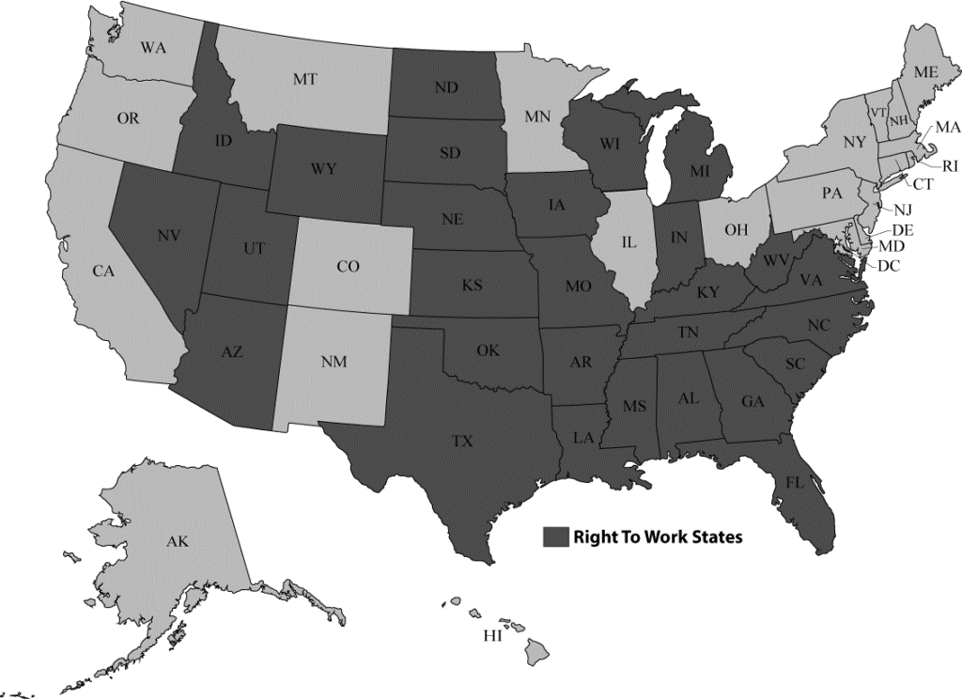
While the Janus decision is limited to public sector workers, in the private sector, the attacks on mandatory union membership have been going on for hundreds of years. A “union security,” or “union shop” clause required any new hire to become a member of the union after a specified period of time.
One attack on the union shop started after World War II with the passage of the Taft-Hartley Act in 1947, reflecting a new and aggressive anti-unionism that had stalled during the war. The law allowed states to individually pass open shop laws—misnamed “Right-to-Work” laws—which explicitly denied a union the right to negotiate a union shop clause. In 1947, there were no open shop states—now there are 27, with more possible—not the direction the arc of history should bend. A heroic petitioning campaign over the past year by union supporters in Missouri blocked an open shop law in that state. The legislature passed the law and Governor Eric Greitens, who proclaimed in his State of the State address January, 2017, that ““Missouri has to become a right-to-work state,” signed it in April, 2017, but the union campaign forced a referendum. Even though union supporters had to collect a little more than 100,000 signatures to block the law, they turned in more than 300,000 signatures to support the popular vote.
The campaign was an enormous success because the vote on August 7, 2018, against Missouri’s Proposition A was 63%, a 2-1 majority, in a state with only 8.7% union membership. “"It's a truly historic moment," said Mike Louis, president of the Missouri AFL-CIO. "Tonight we celebrate, but tomorrow we're getting back to work. We're going to take this energy and momentum and build more power for working people across Missouri."
“Not only did opponents crush the law by a margin of more than two to one, the total vote on the issue—nearly 1.4 million—exceeded by more than a 100,000 the number of statewide ballots cast on behalf of all candidates in both party primaries that same day. . . . In many instances this movement was led—and not merely funded—by the more conservative wing of the Missouri AFL-CIO—the building trades, Machinists, and Teamsters who rightly saw ‘right to work’ as an existential threat. . . . the ballot fight became for many a referendum on class power in the United States: are you for or against unions, with the boss or wary, in favor of Social Security or not, with the rich or against? Such dichotomies sidestepped, perhaps even subverted, the set of racial, religious, and culture-war polarities that have for too long turned the phrase ‘white working class’ into a synonym for Trumpite reaction.”
It is also worth noting that Greitens resigned June 1, 2018, after months of controversy and was facing a now-dismissed felony charge for invasion of privacy against his former mistress and numerous campaign fundraising irregularities.
The next question for the union members in Missouri is—now what? They won a defensive issue and kept a condition which we already had. Now can they organize more workers into unions and reverse the bad political situation?
Can we do the same in every state?
In early 2017, Reps. Joe Wilson (S.C.) and Steve King (Iowa) introduced a national Right-to-Work bill, which had the support of President Trump. “’The president believes in right to work. He wants to give workers and companies the flexibility to do what’s in the best interest for job creators,’ White House Press Secretary Sean Spicer said during the Feb. 3 daily news conference. ‘Obviously the vice president has been a champion of this as well.’”
Even in states where unions could negotiate union shop clauses, however, there were legal challenges that cut into this requirement. In the NLRB v General Motors case (1963) the US Supreme Court ruled that a union could negotiate an agency fee clause, requiring that a worker covered by the union contract who did not wish to become a member pay FULL dues and initiation fees. As a result, workers could continue working under the union contract but were not “members.”
A second attack came in 1988, when a Supreme Court decision in Communications Workers v Beck ruled that unions “are authorized by statute to collect from non-members only those fees and dues necessary to perform its duties as a collective bargaining representative.” Union staff then had to keep track of all expenditures—of time and of money—to satisfy the requirement that money was spent on collective bargaining. The workers were considered “financial core” payers, and not union members. Over the years, different decisions have shifted the financial requirement—is new organizing a “collective bargaining” benefit? –but the ability of a worker to continue under a union contract without becoming a member or paying full dues was established.
* * * * * * * * * * * * * * * * * *
A major political controversy involves the financial stability of government, and who is responsible for growing deficits at every level. Working class advocates claim the reduction in taxes on the wealthy have cut revenues while conservatives blame public employees—stereotyped as overpaid, lazy and incompetent—and workers who collect public benefits, like Medicaid or food stamps and who live in publicly subsidized housing.
One whole element of the Janus case is a basic attack, not just on public sector unions, but on public ownership, by claiming that the unions conspire run up huge public deficits. “Justice Anthony Kennedy suggested that unions were working together with public officials to produce "massive government" and higher taxes. Doesn't it blink reality to deny that that's what's happening here?" Kennedy asked. One right-wing group stated in 2013: “Public-sector unions took forced dues from more than 250,000 public employees in 2013, siphoning away taxpayer money to support the unions’ shared goal of bigger government.”
Wisconsin Governor Scott Walker set the pattern for governors in 2011 when he covered his anti-unionism in a state budget he called “The Budget Repair Bill,” as if he were protecting all workers in the state by devastating public sector unions. ““We can no longer live in a society where the public employees are the haves and taxpayers who foot the bills are the have-nots,” Walker proclaimed in his 2011 inaugural address.
This attack was echoed by Justice Samuel Alito in the Janus decision. “Illinois, like some other States and a number of counties and cities around the country, suffers from severe budget problems. As of 2013, Illinois had nearly $160 billion in unfunded pension and retiree healthcare liabilities. By 2017, that number had only grown, and the State was grappling with $15 billion in unpaid bills. We are told that a ‘quarter of the budget is now devoted to paying down’ those liabilities. These problems and others led Moody’s and S&P to downgrade Illinois’ credit rating to “one step above junk”— the “lowest ranking on record for a U.S. state.” (Janus decision. pp 27-28)
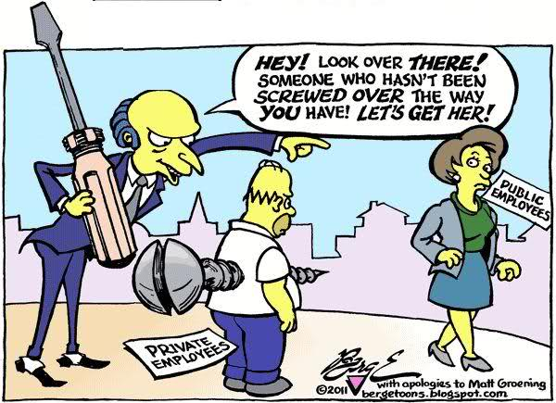
Public-spirited citizen that he is, Mark Janus also presented himself as a defender of fiscal responsibility. In an Op Ed in The Washington Post, Janus proclaimed: “My home state of Illinois is in financial free fall. The state has billions of dollars in unpaid bills, has unbalanced budgets and is bleeding people and money.” Janus makes the outrageous claim about “the incredibly generous, taxpayer-funded pension offered to state workers — an average of $1.6 million per state employee, according to a report from the Illinois Policy Institute.”
“I would gladly forgo my annual raise because it’s more important to me that the state get its financial house in order. I would happily have my pension converted into a 401(k), instead of piling more obligation onto the bankrupt pension fund. But I haven’t had a choice about either of these, and I have been forced to pay for a private organization that I don’t want to be a member of to negotiate for things I don’t believe in.”
In particular, Janus “believes that the Union’s ‘behavior in bargaining does not appreciate the current fiscal crises in Illinois.’” This opposition emphasizes both the anti-unionism of the campaign but also the attacks on public facilities—schools, hospitals, medical programs.
In the Janus decision, Justice Alito noted the union’s position. “But when the State offered cost-saving proposals on these issues, the Union countered with very different suggestions. Among other things, it advocated wage and tax increases, cutting spending ‘to Wall Street financial institutions,’ and reforms to Illinois’ pension and tax systems (such as closing ‘corporate tax loopholes,’ ‘[e]xpanding the base of the state sales tax,’ and ‘allowing an income tax that is adjusted in accordance with ability to pay’).” (p. 29)
Uh, so deficit spending or public policy is a First Amendment issue?
* * * * * * * * * * * * * * * * * *
It is also urgent to understand that the anti-union campaign is not finished simply because of the Supreme Court decision. The legal challenge is simply one part of a comprehensive anti-union disorganizing campaign.
One commentator exposed a four-part strategy to destroy unions in the United States:
- The first part is to continue advancing so-called right-to-work laws to starve union budgets.
- The second part is developing its opt-out campaigns to erode union membership, pioneered in Washington state by the SPN-affiliated Freedom Foundation.
- The third part is to require unions to recertify more often with periodic votes, as Wisconsin’s Act 10 did in 2011. Such mandates saddle unions with regular battles for survival.
- The fourth is to eliminate the right of unions to exclusively represent workers, allowing individuals to opt out of collective bargaining and sign their own contracts
As soon as the decision was posted, a sophisticated web site called My Pay My Say (https://www.mypaymysay.com/) appeared, sponsored by the Mackinac Center for Public Policy, founded by the DeVos family which made its money from Amway. The site has links to every state with detailed instructions on withdrawing as an agency fee payer (or even as a union member), including a dropdown menu for each state listing its public sector unions. The Center boasts on its web page that it has been working for 25 years to get the state of Michigan to pass an open shop law. “Type right-to-work into our website’s search engine and it will return 514 articles, blog posts, special essays and news coverage generated by Mackinac Center analysts,” states a column by Michael D. LaFaive.
As part of its organizing campaign, the Center has a note at the bottom of each page: “I allow MyPayMySay.com to store this information in order to help public employees exercise their rights when it comes to union dues, fees and representation. It may be used to contact or follow up with you.”
“The Mackinac Center is planning to spend $10 million this year and $40 million to $50 million over the next two or three years on a “national awareness campaign.” The organization has already opened a national call center, staffed around the clock by 20 trained representatives, to help public employees opt out. It will also fund canvasses and literature campaigns across the country, said Lindsay Killen, the vice president for strategic outreach and communications at the Mackinac Center.”
The state of Illinois immediately posted a web page called Change Your Membership Status, proclaiming “As a result, effective immediately, the State will stop deducting "fair share" fees from the paychecks of State employees who are not union members. Going forward, State workers may choose to either be members of a union or non-members – there will be no ‘fair share’ designation.”
The page contained detailed instructions on how to withdraw from a union, and the most blatant appeal, right out of Marty Levitt’s playbook: “Unions are still obligated to fairly represent all employees in collective bargaining, whether they are members of the union or not. Of course, your decision to join or withdraw from the union will not impact your job protections with the State. You will NOT lose your employment benefits if you opt-out of the union. Illinois statute requires the State to provide healthcare benefits, retirement benefits and many other employment benefits. They do not depend on union membership or collective bargaining. In addition, even if you opt-out of the union, you still receive the same employment benefits as union members.”
Other states also immediately posted information about the Janus decision and about the procedure for agency fee payers to withdraw completely from a union. In Oregon, a web site called OptOutAFSCME, has forms to withdraw and another series of anti-union presentation, like:
Will the union stop helping me with workplace issues?
The union has been recognized by the state as the “exclusive representative” of all members of the bargaining unit, whether formal union members or not. In return for the monopoly on this particular service, unions have a corresponding legal duty to provide fair representation.
These web sites are part of a sophisticated and comprehensive anti-union campaign, supported by the Freedom Foundation, a creation of the Koch Brothers, to devastate public sector unions on the west coast. The Freedom Foundation
“will deploy 80 people to a trio of West Coast union bastions: California, Oregon and its home state of Washington. The canvassers were hired in March and trained this month, according to internal documents reviewed by Bloomberg News. The goal of the multi-pronged campaign is to shrink union ranks in the three states by 127,000 members—and to offer an example for similar efforts targeting unions around the country. . . . In February, it began acquiring lists of workers and identifying public employees to feature in anti-union videos. This month, it has been assembling materials to provide to sympathetic local-government human resources departments and readying a toll-free call center. . . . the Freedom Foundation reported a 2016 budget of $4 million. Its current assault on unions is modeled on past efforts that targeted home health aides, who in 2014 were given the option of not paying fees, and other government workers, who had a choice of paying full dues or smaller representation fees. Nelsen declined to identify any of its donors, which he said include businesses, foundations and individuals ‘from all different walks of life.’ All donations are “made by those who believe in our mission,” he said. However, tax filings reveal a who’s-who of wealthy conservative groups. Among them are the Sarah Scaife Foundation, backed by the estate of right-wing billionaire Richard Mellon Scaife; Donors Trust, which has gotten millions of dollars from a charity backed by conservative billionaire brothers Charles and David Koch; from the Richard and Helen DeVos Foundation, backed by the family of U.S. Secretary of Education Betsy DeVos; and the State Policy Network, which has received funding from Donors Trust and is chaired by a vice president of the Lynde and Harry Bradley Foundation. . . . According to the group’s documents, targets for its new ‘insurgency’ campaign include corrections officers and teachers, who will be out of school for the summer and thus ‘have no interaction with their union.’ Because the Oregon chapter of the American Federation of State, County and Municipal Employees, or Afscme, has been preparing members by ‘aggressively messaging’ them, the anti-union group’s documents state, taking a more patient, less-aggressive approach with those workers will help to ‘demonize’ the union.”
In another state, “New Choice NY, is now advising union members of their right to stop paying regular dues, as well non-union members who had been forced to cough up so-called ‘agency’ fees.’ ‘Want to exercise your right to stop paying dues? Use this form,’ the group, an affiliate of Americans for Fair Treatment, proclaims on its website in guiding government workers how to quit their unions. Americans for Fair Treatment’s three-member board includes the CEO of the right-leaning Commonwealth Foundation in Pennsylvania, which is backed by donors linked to the anti-union billionaire Koch brothers, The Philadelphia Inquirer reported. New Choice NY spokesman Bob Bellafiore insisted his group is about providing workers ‘factual information’ about their rights, not busting unions.”
“The Buckeye Institute has launched a campaign called “Workers Choose” to let employees know about a Supreme Court decision issued June 27 that its says “recognized the right of public employees to choose whether to financially support their union.” The Institute is described as “a nonpartisan, nonprofit entity based in Columbus, Ohio, which advocates for what it calls free market public policies in the states,“ and immediately filed suit in federal court in St. Paul, MN, in behalf of a professor at St. Cloud State University” over alleged faculty union control of certain committee assignments. In a different attack on unionism, this court case is also challenging the principle of “exclusive representation”—only one union representing the workers at a location or employer.
“Meanwhile, the Mackinac Center, an SPN [State Policy Network, the web of billionaire-backed right-wing groups that helped fund the Janus v. AFSCME lawsuit] affiliate, publicly launched an opt-out hotline for union members across the country. The California Policy Center, another affiliate, sent a fundraising email to 8,000 union social service workers in Los Angeles County with the stated goal of reducing union dues “by $300 million in the next three years.”

The Pennsylvania-based Americans for Fair Treatment—an organization formed in 2014 whose four board members are SPN-affiliate employees—recently hired a former teacher and anti-union activist to lead an opt-out campaign targeting the state’s 330,000 public employees. SPN spokesperson Carrie Conko confirmed to the Wall Street Journal that the network is providing support to opt-out campaigns in Illinois, Michigan, Ohio and Pennsylvania. . . . To extend the campaign, groups like the Freedom Foundation have been using the Freedom of Information Act to get lists of state employees. “The Freedom Foundation described obtaining the contact information of 300,000 public employees in Washington using open records requests as being ‘like a prospector locating a vein of gold.’ The Freedom Foundation claims that its multiyear campaign cost SEIU 925 two-thirds of its members. The union confirms this loss rate but attributes it to a high-attrition workforce, not the opt-out campaign.”
“’Labor bosses are the single greatest threat to freedom and opportunity in America today,’ he [Tom McCabe, chief executive officer of the Freedom Foundation] wrote. ‘By taking money from hard-working, dues-paying Americans, they’re funding a broken political culture in states like Oregon and Washington.’ His fundraising letter added: ‘The Freedom Foundation has a proven plan for bankrupting and defeating government unions through education, litigation and community activism.’”
* * * * * * * * * * * * * * * * * *
So now we know all of the things the bosses are doing to us. What do we do?
As Janus reversed a decision on the same topic from 1977, it’s another illustration of the phrase ”there’s no more normal.” The emphasis just on the decision, and on how Five Old Men can drastically affect unionism is a real mistake, however. This legal case was a small part of a huge, relentless and well-funded organizing—or disorganizing—campaign to eliminate unionism in the US. We have to confront the challenge with our own organizing strategies, and not just legal maneuvers—either we meet it and beat it or our movement is done.
“When the Janus opinion is issued, some celebrity appeal to rally union support will roll out, [SEIU President Mary Kay] Henry said, from SAG-AFTRA and the NFL players unions to actress Sally Field, who stood on a desk holding a sign simply saying “union” in a powerful iconic scene from her 1979 film, ‘Norma Rae.’”
To her credit, Henry also created a nationwide committee within the SEIU, including leaders from across divisions in the US and Puerto Rico, called Together We Rise, headed by union Vice-President Neal Bisno to sign up non-members. “The work was very focused on preparing for the Janus decision and on innovating how local unions can survive and thrive in open shop environments. Across SEIU we signed up more than 50,000 new members from Fair Share to full membership and set Local by local goals for member leaders. It’s a start at least! Now we are focused on leadership training/new member orientations and on-boarding processes. Everyone focused hard on incumbent non-member fair share workers until the decision and are now focused on the new members and retaining existing members.”
While the anti-union forces moved rapidly to encourage agency fee payers to drop out, and states like New York announced that it would no longer administer check-off for agency fee payers, the officers of the AFL-CIO could only propose new legislation, called The Public Service Freedom to Negotiate Act of 2018. The legislation is authored by Sen. Mazie Hirono, D-Hawaiʻi, and Rep. Matt Cartwright, D-PA., and co-sponsored by 31 Senate and 19 House Democrats, including Senate Minority Leader Chuck Schumer, D-N.Y., and House Minority Leader Nancy Pelosi, D-CA. While Bill Samuel, the Government Affairs Director for the AFL-CIO, sent out a message urging people to sign an electronic petition in support of the bill which, “if passed, would strengthen public employees’ right to join a union and give them access to dispute mechanisms at work,” the proposal was savaged by anti-union political strategists.
“’This bill would force all 50 states to give monopoly bargaining powers to Big Labor, in a gross violation of the rights of public employees and the rights of those states’ policymakers. Monopoly bargaining has been a failure in the private sector, and a disaster in the public sector, for every state that has implemented it,’" said Greg Mourad, vice president of the National Right to Work Committee. "’Now the national Democrats want to force it on the rest of the states as well. It’s an obvious payback to the union bosses who spend $2 billion every election cycle to help them get elected.’"
In May, 2018, in anticipation of the Janus decision, new federal legislation was introduced.
“The Workplace Democracy Act would make it easier for workers to join unions in a number of ways:
- It would end right to work for less laws by repealing Section 14(b) of the Taft Hartley Act, which has allowed 28 states to pass legislation eliminating the ability of unions to collect fair share fees from those who benefit from union contracts and activities.
- Under the legislation, when a majority of workers in a bargaining unit sign valid authorization cards to join a union, they must have a union. Companies would not be allowed to deny or delay a first contract with workers who have voted to join a union. Unions would be given the right to have their voice heard through secondary boycotts and picketing. And workers would have the right to know when their company spends millions of dollars running anti-union campaigns.
- The bill would also stop employers from ruthlessly exploiting workers by misclassifying them as independent contractors or denying them overtime by falsely categorizing them as a “supervisor.”
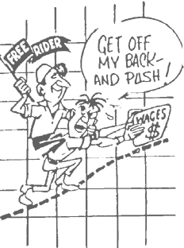
Unions also began reorganizing campaigns. “The SEIU has its ‘Together #WeRise drive;’ ‘AFSCME Strong in Illinois’ was launched last August. The unions have been using all their tools: direct personal contact, organizer training, videos, fact sheets, ads, townhalls, flyers and direct mail. AFSCME Council 31, SEIU Local 73 and the Chicago Teachers Union start out with most of their eligible workers already dues-paying union members. ‘In a very real sense, we are taking a very negative situation and remaking it as a way to deepen and strengthen our union and grow even stronger,’ [Anders] Lindall said. AFSCME Council 31 represents more than 70,000 Illinois workers and 90 percent are dues-paying members, Lindall said. SEIU Local 73 with about 29,000 members in Illinois and northwest Indiana grew by about 800 members between August 2017 and March 2018, according to spokesman Jesus Canchola Sanchez. The Chicago Teachers Union 23,681 members take in 98 percent of eligible Chicago Public Schools workers.”
The union response has been to reach out the members in many states about the implications of the anti-union campaign and to also try to block the anti-union foundations from getting access to the names and addresses of public workers.
“’It’s critically important to inoculate members against these organizations,’ says SEIU 925’s Karen Hart. ‘We made the mistake of talking about how great the union is and not talking about the Freedom Foundation, so folks got this information and didn’t understand who it was coming from.’”
Hawaiʻi has an especially favorable political approach to the threat of the Janus decision. In 2017, H.B. No. 923, stated:
SECTION 1. The legislature finds that Hawaii's collective bargaining in public employment law, chapter 89, Hawaii Revised Statutes, was enacted to promote labor management harmony in the public sector by:
(1) Establishing guidelines for employment relations relating to wages, hours, and working conditions;
(2) Providing a method for dealing with disputes and work stoppages; and
(3) Maintaining a favorable political and social environment.
The legislature further finds that the policy to promote harmonious and cooperative relations between government and its employees rests on the right of public employees to organize for the purpose of collective bargaining, in accordance with article XIII, section 2, of the Constitution of the State of Hawaiʻi.
The legislature also finds that changes in federal constitutional law could have an impact on public employee collective bargaining in Hawaiʻi. . . .
The legislature finds that should the United States Supreme Court strike down laws requiring the payment of union dues by public sector employees, such a ruling would fundamentally undermine this legislature's consistent efforts to ensure labor management peace. Not only would such a ruling effectively hamstring the collective bargaining representative's ability to collect resources from its membership, it would greatly diminish the public employee's ability to negotiate with management.
Accordingly, the purpose of this Act is to ensure that public employees are able to effectively collectively bargain with the public employer by establishing a mechanism that will provide the exclusive bargaining representative with the resources necessary to adequately represent public employees.”
The proposed bill, introduced in January, 2017, establishes a “Public Employees Collective Bargaining Fund,” based on a percentage of state worker compensation, which will be distributed to the exclusive bargaining agents “to promote harmonious and cooperative relations between government and its employees and to protect the public by assuring effective and orderly operations of government.”
The bill never got out of committee in either 2017 or 2018, and the one legislator signed on to introduce the bill, Marcus Oshiro, left the legislature later in 2017 to take a position with the Hawaiʻi Labor Relations Board.
One failure of the union movement since World War II has been the inability to organize in many states. More than half (7.9 million) of the 15.7 million union members in the U.S. lived in just six states (California, New York, Illinois, Michigan, Ohio, and New Jersey), and even where union membership—on paper—is high, the union movement has been beaten badly politically. In both Illinois and Michigan, for example, openly anti-union governors were elected—and re-elected in Michigan-- so agency fees were either challenged, as in Illinois, or cancelled, as in Michigan which became an open shop state in 2012. As part of the anti-union campaigns that were unfortunately so successful, unions in Wisconsin, Michigan, Indiana, and Iowa lost agency fees after 2010.

While there has been some hot rhetoric about the decision--““The cork is out of the bottle. This is an orchestrated attack on the labor movement. If they think they’re going to dupe or trick hardworking union members, they have another think coming” proclaimed Mario Cilento, President of the New York State AFL-CIO—it will only be blocked only if union members at every level—officers, staff, members, retirees--change their attitudes and strategies or else we will be shown to be, by Einstein’s definition, insane.
The membership numbers and political defeats demonstrate that the union movement in the US must totally change the way it functions. Suggested changes for the basic functions of the unions—grievances, contract negotiations, organizing and political action and their financial priority—are covered in detail in the two books, Closing Up the Open Shop: A Guide to Internal Organizing and Don’t Trump On Us: Making Our Unions Great Again.
One unique observation came in Hawai’i, where the president of the Grassroots Institute stated:
“Already, the Hawaiʻi Legislature is pondering how to respond if the Supreme Court rules in favor of Janus. But the people who are wrapped up in the political implications of the Janus case are ignoring an opportunity that may actually benefit our public sector unions. Though unions are treating Janus as though it is a threat to their existence, it's possible that this case could be an opportunity for our state employee unions to modernize and become more responsive to their members. If the members consider their unions to be valuable voices for their interests, they will gladly support them, even if the dues no longer are mandatory. If they choose not to pay the dues, the unions will know that they need to change their ways to keep their members satisfied. In a sense, Janus would simply give the unions a taste of the free market. It's easy to see why they would prefer the status quo, but a little change doesn't have to be a bad thing.”
There are examples of the workers movement becoming powerful and exciting again. The surge of public sector organizing by “unhappy” teachers in the spring, with walkouts in West Virginia, Oklahoma, Colorado, Arizona and Kentucky show the enormous anger of public sector workers. The walkout also illustrates the complex position of unions because these are states where Janus will have no impact because they do not have public sector bargaining laws.
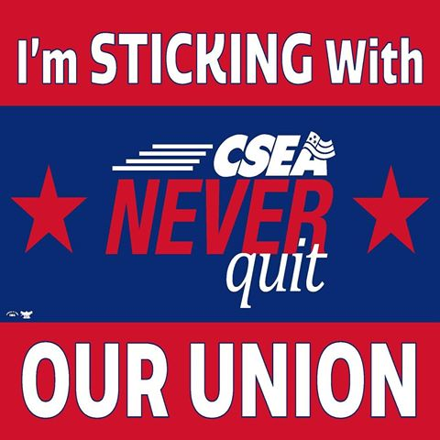
From an organizing perspective, the numbers were astonishing and encouraging as the teacher walkouts spread across the country. In the open shop state of Arizona, for example, there are 90,000 certified teachers but only about 20,000 (22%) were members of the Arizona Education Association. When it came time to vote in April, 2018, on a strike for both increased salaries and more spending on public schools, however, 57,000 (63%) filled out a ballot, and a poll showed that 78% of the teachers supported the strike. A huge majority of the teachers risked discipline by walking out of their schools, even as a state legislator “proposed amendments to make it illegal for teachers to espouse political beliefs at work, to require the attorney general to investigate schools that allow political activity and to bar schools from closing during a walkout.”
With some strong activity, participation in the union tripled! Build it and they will come.
The whole issue of “labor peace” was raised by Robert Bruno, who discussed “the effects” of a negative decision in Janus. “Labor unrest is chief among them. The school walkouts that have recently come to West Virginia, Oklahoma, Arizona and North Carolina — and the poor pay and working conditions that precipitated them — each occurred in states without collective bargaining laws for public sector employees permitting fee payer provisions.”
It is still to be determined whether the teachers’ campaign will become an expanded union movement or if it will become, like the Occupy Movement, a vivid
and exciting moment with no lasting effects. For 2018, however,
“Nearly 300 members of the American Federation of Teachers union are running for political office this year, more than double the number in each of the years 2012 and 2016. The teacher candidacies are part of a rising tide of political activism in 2018, with nearly 800 candidates running in the first round of Oklahoma's primaries, breaking the previous record of 594 set in 2006, and more than 200 filing to run in next month's Arizona primary — more than ran during each of the previous three election cycles. The teacher candidacies suggest that the wave of teacher strikes and protests that began last winter in West Virginia and later spread to Oklahoma, Arizona and elsewhere created a grass-roots political opportunity. . . . Teachers unions, meanwhile, are hedging on their commitment to the Democrats amid the national political circus. Although the Oklahoma Education Association's crop of candidates is overwhelmingly Democratic — just six of 33 candidates are running as Republicans — the OEA hasn't forgotten that its membership is split evenly between Republicans and Democrats, said OEA President Alicia Priest. “We're really pushing 'vote your job,'” Priest said. “Public education is your paycheck and your passion, and you need to vote as though it is. . . . The fallout from the teacher protests is even reaching deep-red Arizona. One hundred fourteen Democrats will compete in the Aug. 28 primary for legislative seats — the most on record, according to the Arizona Democratic Legislative Campaign Committee. Teachers are also running a ballot measure campaign that would tax the highest income earners for an additional $690 million to spend on schools.”
A more instructive, and conflicted, approach to increasing membership was presented by the president of the Baltimore Fraternal Order of Police, Gene Ryan, who not only said that “the majority of officers are union members,” but stressed “In 2016, union members voted unanimously to double their dues in order to keep the union solvent. . .”
The impact is that the money was then used to pay legal expenses for six officers criminally charged in the death of Freddy Gray, a young African-American man whose neck was broken while in a police van. The conduct of police, and their union’s defense of these officers is a controversial union practice, of course, but the lesson is that when the union provides benefits, the workers will join—and will even vote to double their union dues!
How would that pass in your local?
Most importantly, every union member has to support our original slogan ”An injury to one is an injury to all.” In many states, which continue union security, private sector unions have not been involved in the struggle against Janus. They figure “it’s not our fight,” but as the private sector unions learned, to their sorrow in states like Wisconsin and Michigan, attacks on the public-sector unions are simply part of a plan to obliterate all unions.
And then they came for us . . .

Bill Barry is a retired union organizer and educator who lives in Baltimore, MD. He is the author of Closing Up the Open Shop: A Guide to Internal Organizing, Don’t Trump on Us: Making Our Unions Great Again and I Just Got Elected, Now What: A New Union Officer’s Guide. He can be contacted at billbarry21214@gmail.com
TWO MODELS OF UNIONISM

When unions were first organized, the workers’ success depended on total membership involvement since the early organizations had no resources except the passions of the members and their communities. As unions became more established, this Organizing Model of Unionism gradually was replaced by The Servicing Model of Unionism, which became the dominant structure for unions. In the mid-1990’s, as some union officers recognized the desperate situation for unionism, The Organizing Model was revived, at least as a discussion topic.
This chart shows the differences between the two models.

ORGANIZING MODEL SERVICING MODEL

Proactive Reactive

Independent of management Dependent upon management

Actively involves members in all decisions Union officers “solve problems” for
members in response to complaints or
requests

Creates many activities in workplace Total reliance on grievance and arbitration

Constantly negotiating for improvements Waits for regularly scheduled contract dates

Develops the skills and abilities of the Total reliance on union staff, “experts” and members lawyers

Open communications channels Union info is considered privileged and
kept secret to a small group

Active membership Passive membership

Decentralized union structure Centralized union structure

Bottom-up decisions Top-down decisions

Regularly supports other unions Basically isolated from other activity

Worker/Union Leadership

”Leadership means moving people, moving our coworkers. An elected or appointed union representative is not necessarily a leader.”
--A Great Authority
Good Leadership Bad Leadership
Kaizen Is easily satisfied
Initiative Passive
Proactive Reactive
Works hard Does the minimum required
Self-reliant Dependent
Self-starter Waits to be told what to do
Persistent Quickly discouraged
Positive Negative
Does not quit Gives up easily
Sets goals Bumps along
Does more than needed Does the minimum to get by
Seeks new information Closed mind
Absorbs and uses new information See above
Ready to change Resists change
Accepts pressure to improve Resists pressure to improve
Finishes tasks in full, on time Owns a bagful of excuses

WHICH ONE ARE YOU?

The Cash Value of My Union Contract

By law, an employer is only required to
- pay minimum wage of $7.25/hour (or any higher state/local rate)
- pay OT at time ½ for all hours over 40 in a week
- provide workers compensation
Everything else has been won by the union in negotiations. Let’s add up our negotiated gains to see how much we get!

Hourly wages $_____(current wage)- $7.25/hour =_______x 2080= $_____

Daily OT (over 8) or double time (x number worked in year) $_____

Evening/night differentials (x hours worked in a year) $______

Health insurance (employer’s annual contribution) $_____

Other insurance -dental, life, etc. (employers’ annual contribution) $_____

Pension/401K (employer’s annual contribution) $_____

Paid holidays (Day rate x number of holidays) $_____

Paid vacations (day rate x number of days) $_____

Other paid days off (personal, sick days, jury duty, bereavement) $_____

Working conditions (work clothes, safety equipment, etc.) $ _____

Other benefits (tuition, travel, etc) $_____

TOTAL ANNUAL INCOME $_____

Now subtract your annual union dues (which are tax-deductible!) $_____

And the cash value of your union contract is (ka-ching) $_____

The Cash Value of a Union Contract For New Hires
One of the big mistakes in thinking that because the ATU Local cannot arbitrate a discharge during the one-year probation period, is that “the union can’t do anything for me” so why should I join and pay dues?
Let’s look at this contract to see how much new hires get for their union dues right away.
By Article 12/Section 4. All non-insurance related benefits will begin from the first day of employment.
Article 6. Protection under the Non-Discrimination article
Article 20. Time 1/2 for working on a designated holiday
Article 21. Annual leave immediately accumulated at 3.10 hours/pay period
Article 22. Sick leave immediately accumulated 3.8 hours/pay period
Article 23. Bereavement Leave
Article 24. Guaranteed 40-hour work week
Article 35. Overtime for Regular Bus Operators at 1 ½ over 8, or over 10 (per schedule)
Article 38—new uniform allowance of $150 after 30 days
Article 40—tuition reimbursement of $1,500/year
Article 44—shift differential in Maintenance of $ .60/hour
Article 45--Starting pay- $13.669 for operators
$14.886 for utility workers
$26.10 for maintenance workers
Florida minimum wage is $ 8.05/hour
Health, Life, Dental and Disability insurance begin the first of the month following 60 days of employment
Article 37.—insurance includes Medical, Dental, Vision, Long Term Disability (LTD), and Life Insurance programs—just the family health insurance, negotiated by your union, costs the employer $4.15/hour and we only pay union dues of $ .22/hour
Bill Barry.
With help from the officers and members of ATU Local1577 in Palm Beach, FL

David Moberg. “Billionaire Governor Bruce Rauner Declares War on Illinois State Unions Through Executive Order.” In These Times. February 11, 2015.
Mitchell Armentrout. “Mark Janus quits state job for conservative think tank gig after landmark ruling.” Chicago Sun-Times. July 20, 2018.
Bureau of Labor Statistics. “Union Membership.” January 19, 2018.
Nathan Eagle. “Why Union Support Matters in the Hawaii Governor’s Race.” Honolulu Civic Beat. July 11, 2018.
Lorraine Mirabella. “Unions call ruling blow to workers.” The Baltimore Sun. June 28, 2018.
Len Lazerick. “State employee unions will start collecting fees from non-members.” Maryland Reporter. July 5, 2011.
Lynn Sweet. “Unions, anticipating Janus case Supreme Court loss, jump-start recruiting drives.” Chicago Sun-Times. June 28, 2018.
Hawai’i Free Press. July 9, 2018
Stewart Yurton. “Hawaii Economists: Public Employee Union Membership Is Bound To Drop.” Honolulu Civil Beat. June 27, 2018.
Moshe Z. Marvit. “For 60 Years, This Powerful Conservative Group Has Worked to Crush Labor.” The Nation. July 5, 2018
Cynthia Estlund and William E. Forbath. “The War on Workers.” New York Times. July 2, 2014.
“After Janus, Another Key Lawsuit Targeting Unions: How California’s Yohn Case Targets Opt-Out Rules.” T74. June 29, 2018.
Noam Scheiber. “Trump Nominee Is Mastermind of Anti-Union Legal Campaign.” New York Times. July 18, 2018.
“Oregon labor group to refund worker's union dues, a first since Supreme Court ruling.” Associated Press. July 30, 2018.
Scott Thistle. “State workers drop mandatory union fees in favor of more pay.” Portland Press Herald. August 31, 2017
Steve Mistler. “Union Director Resigns, A Day After Maine State Employees Accept New Contract.” Maine Public Radio.
Nelson LIchtenstein. “How Missouri Beat ‘Right to Work.” Dissent. August 14, 2018.
Tyrone Richardson and Ben Penn. “Trump Administration Puts Support Behind Right-to-Work Laws.” Bloomberg Law. February 7, 2017.
Mike Janus. “Why I took my case over forced union dues to the Supreme Court.” Washington Post. July 1, 2018.
Chris Brooks. “How Corporations Plan To Use Janus To Turn Workers Against Their Own Unions.” In These Times. July/August, 2018.
Erica Green. “Teachers Unions Scramble to Save Themselves After Supreme Court’s Blow.” New York Times. July 14, 2018
https://www2.illinois.gov/sites/TeamIllinois/LaborRelations/Pages/Change-Union-Membership-Status.aspx
https://www.optouttoday.com/afscme-75-state-employees
Josh Edelson. “Koch Brothers-Linked Group Declares New War on Unions.” Bloomberg. June 27, 2018.
Carl Campanile. “Group wants to teach workers how to stop paying union dues.” New York Post. July 5, 2018
Dan Browning. “St. Cloud State professor alleges forced union representation violates her rights.” Minneapolis Star-Tribune. July 6, 2018.
Chris Brooks. How Corporations Plan To Use Janus To Turn Workers Against Their Own Unions.” In These Times. July/August, 2018, issue
Stephen Greenhouse. “The door-to-door union killers: rightwing foundation takes labor fight to the streets.” The Guardian. March 10, 2106.
Lynn Sweet. “Unions, anticipating Janus case Supreme Court loss, jump-start recruiting drives.” Chicago Sun-Times. June 28, 2018.
Jamie Gulley. Healthcare/Minnesota. Conversation with the author. July 25, 2018
Sean Higgins. “Democrats introduce bill to strip workers of rights won under Supreme Court union ruling.” Washington Examiner. June 28, 2018.
Press Release from Representative Mark Pocan (WI). May 9, 2018.
Lynn Sweet. “Unions, anticipating Janus case Supreme Court loss, jump-start recruiting drives.” Chicago Sun-Times. June 28, 2018.
Chris Brooks. How Corporations Plan To Use Janus To Turn Workers Against Their Own Unions.” In These Times. July/August issue
https://www.capitol.hawaii.gov/session2018/bills/HB923_.HTM
Keli'i Akina. “Hawaii unions need not fear Janus case.” February 2, 2018.
Robert Bruno. “Commentary: A Supreme Court ruling for Janus would be judicial activism at its worst.” Chicago Tribune. May 21, 2018.
Ian Jullgren. “‘Educator spring’ spawns wave of teacher candidates.” Politico. July 4, 2018.
Lorraine Mirabella. “Unions call ruling blow to workers.” The Baltimore Sun. June 28, 2018.

