The Janus Decision: Now what?
By Bill Barry

“The threat is the thing. The most important thing in motivating the members is the threat. Understanding the gravity of the threat is what produces action.”
--Kaye Robinson, former president of the National Rifle Association

After the Supreme Court issued its Janus v AFSCME decision on June 27, cries of calamity could be heard from unions all around the country, as if the sky were suddenly falling in. Union officers who never send out communications about union activities suddenly were on-line with predictions of doom and commitments to rebuild their unions. There was a sudden flurry of discussion, not just about the decision, but about the future of unionism in the US, and even on the impact of the decision on liberal political groups which are financially supported by union officers.
As Janus reversed a decision on the same topic from 1977, it’s another illustration of the phrase ”there’s no more normal.” The emphasis just on the decision, and on how Five Old Men can drastically affect unionism is a real mistake, however. This decision was a small part of a huge and relentless campaign, cleverly organized and well-funded, to eliminate unionism in the US and we have to meet it and beat it or our movement is done.
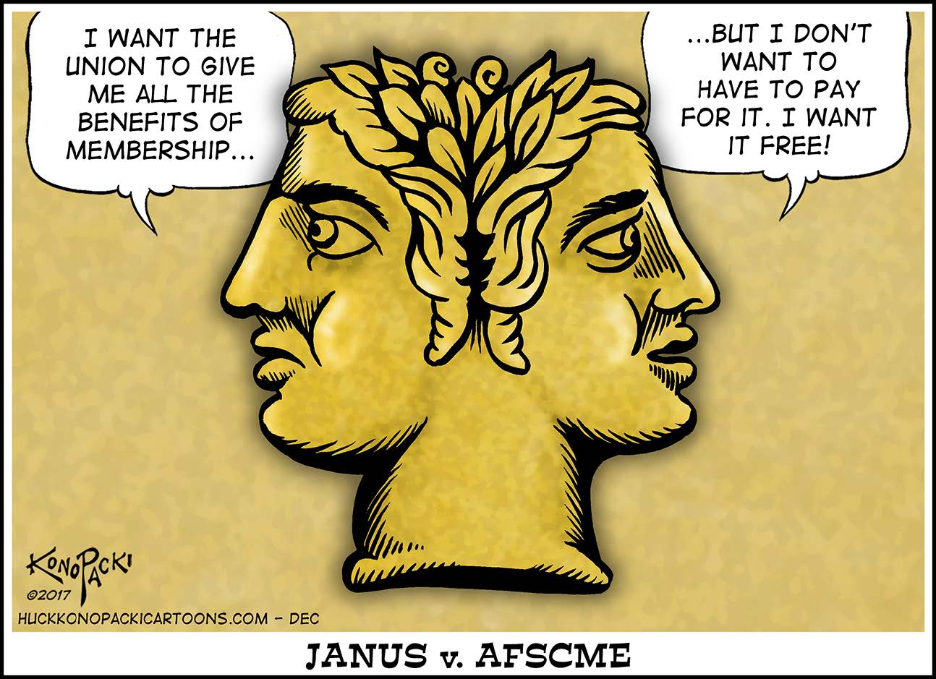
So what is the Janus decision and how serious are the consequences? If you have not followed the case, it was brought in behalf of Mark Janus, (or j.Anus) a child-support specialist, and two other workers in Illinois, who claimed that their First Amendment rights were violated when the state passed a law requiring payment of “fair share,” or “agency” fees. Workers covered by the union contract who do not want to join the union must pay in a sum of money—less than full union dues—to cover the cost of enforcing the contract and negotiating new ones. Janus is covered by an AFSCME contract, part of a unit of approximately 35,000 workers.
Other states have passed “enabling legislation,” allowing unions to negotiate contract clauses that mandate payment of agency fees. The argument in favor of such a law is obvious: all of the workers covered by the contract negotiated by the union get the benefits, and the union may be required to represent every worker, so it is only fair that every worker contribute some money.
If workers choose to pay only the agency fee, they are not considered full members in good standing of the union. They cannot attend union meetings, they can’t vote in union elections or on new contracts without special permission from the members and officers. Many union have implemented special benefits plans, like Union Privilege, which are limited to full members.
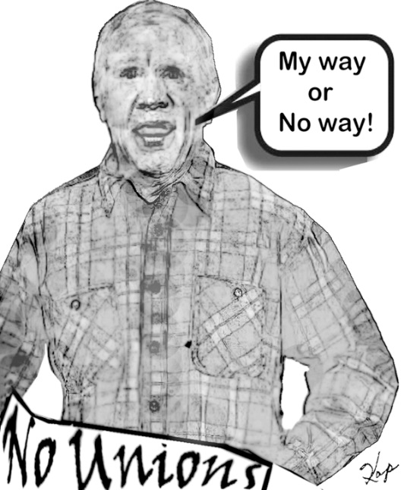
Mark Janus, with the financial support of a block of right-wing foundations like The National Right to Work Legal Defense Foundation (NRTWLDF), stepped up when a federal judge ruled that Illinois Governor Bruce Rauner “had no injury or stake in the suit” and therefore had no standing to challenge the law in court. A millionaire investment banker elected in 2014, Rauner had built a whole campaign on anti-unionism. In his first State of the Union address in January, 2015, he announced that all “unfair share” money from 6,500 agency fee payers (out of a state workforce of 78,000) would be held in escrow by the state. By extending an Executive Order, Rauner bypassed the state legislature. He also stated that he “will encourage local governments to pass such right-to-work laws, referring to them as ‘employee empowerment zones,’ which permit workers to refuse to pay any fee to unions that, by federal law, are required to represent them if the union is the recognized bargaining agent in the workplace.”
Rauner’s continued campaign to eliminate the agency fee clause, negotiated by his predecessor, Pat Quinn, is an example of why the whole Janus case is not just a legal issue, which union officers fought by picketing the Supreme Court, but is part of a comprehensive anti-union campaign that must be confronted with a strong nationwide union strategy.
While the 5-4 decision supposedly looked only at obscure legal issues—is it a violation of the Constitution to collect these fees? Can the Supreme Court reverse a previous decision?—the social policy and anti-union strategies reflected in the case are very important for every union member (and non-member), in both the public and private sectors.
As an appreciation for the anti-union strategy, this is the second case to get to the Supreme Court in which the First Amendment was used as a cover by an anti-union worker, with the financial support from right-wing money. Several years ago, the case Friedrichs v California Teachers Association used the same flimsy Constitutional argument but was blocked in January, 2016, by the death of Supreme Court Justice Antonin Scalia and the justices had a 4-4 decision in March, 2016. The success of the Trump administration in confirming Justice Neil Gorsuch in April, 2017, provided the decisive vote in this very important Janus decision.
The question is how serious are the consequences of this decision? Obviously, the decision, and other law suits like Friedrichs v California Teachers are part of a relentless and shrewd (and, of course, well-financed) plan to eliminate unionism in the United States. But the US has become an open shop country, so Janus is simply one more step in a long—and for unions—losing struggle.
Union membership in the private sector reached a peak of 37% in 1959, and union contracts set a pattern for all industries, creating “the middle class” in the US. In 2017, however, The Bureau of Labor Statistics showed, “The union membership rate of public-sector workers (34.4 percent) continued to be more than five times higher than that of private-sector workers (6.5 percent).” So public sector unions, and the laws which protect their revenues, are now Target # 1.
These attacks are designed to create dissension in every workplace and to reduce union membership. The attacks have unfortunately been successful—union membership in the country in 2017 was 14.8 million, about the same number as in 1946. The percentage of private sector workers in a union was only 6.5%, about what we had in 1900. The direction of unionism in the US since the 1940s has been downhill, and Janus is just another step in a direction we must reverse—and quickly.
Hawai’i is the country’s second most-unionized state but even here, the direction has been downward. “There were 129,000 union members last year in Hawaii, according to the U.S. Bureau of Labor Statistics. That’s a little more than one out of every five workers — double the national average but down considerably from the state’s peak of 30 percent in 1989.”
A common mistake about Janus is the belief that somehow—just as we are all required to pay taxes— public employees are automatically forced to pay agency fees. In fact, one important point missing from a lot of this discussion is that only 22 states—less than half of the country—have laws that authorize agency fees.
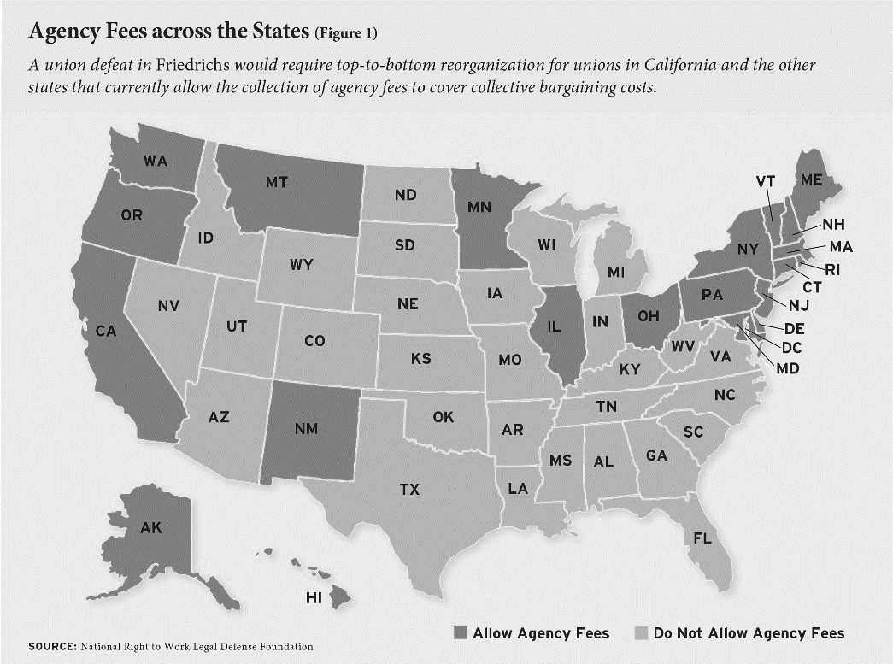
Even within these states, there are more limitations. In Maryland, for example, only five counties—out of 23-- and the City of Baltimore have legislation permitting unions to try to negotiate an agency fee clause. The counties are the urban ones and since contracts are negotiated locally, the other jurisdictions are already open shop and will not be directly affected by the Janus decision. The Maryland Teachers Association (MTA) which represents 74,000 teachers across the state, noted that there are 3,000 agency fee payers and about 18,000 non-members state-wide, so about 28% of teachers covered by an MTA contract are already free riders.
The former governor of the state, and 2016 presidential hopeful, Martin O’Malley supported legislation in 2011 to let unions for state workers negotiate an agency fee clause. At that time, one source reported “AFSCME represents 21,000 employees throughout state government, and about 8,500 of them are members of the union.”
It is important to recognize that the Janus decision is limited to public sector workers. Beyond these limits on negotiating agency fees for public workers are two enormous public sector open shops: the federal government and the US Postal System.
At the same time, the decision will, at least temporarily, have a disastrous impact on public sector unions. Announcing that the state of New York will no longer deduct agency fees, State Comptoller Tom Di Napoli estimated that there have been 31,000 state workers paying the service fee.
“The Illinois Economic Policy Institute, in a study released May 9, painted a dire picture for government worker unions if Janus prevails. In 2017, Illinois had 317,000 state and local government union members and would, with a Janus win, lose over a few years 49,000 members, the study estimated.”
The impact on public sector unions in Hawai’i is not clear because state Comptroller Roderick Becker said that the state’s payroll record does not distinguish between union members and agency fee payers. The office “asking unions to confirm whether or not they have a non-member population and to provide the names of those members to the state. Once the names of nonmembers have been provided, agency fee withholdings will be suspended.”
“Public employee unions have big memberships and play a prominent role in Hawaii’s economy and politics. The Hawaii Government Employees Association, which represents a number of government employees, has 42,000 members. The United Public Workers union has 14,300. . . . The Hawaii State Teachers Association, the state’s fourth-largest union, has a 99 percent rate of membership, counting 13,700 individuals, according to president Corey Rosenlee. Slightly more than 100 Department of Education teachers are not members. . . . Could Hawaii defy the economic theory? Richard Rand, a Hawaii labor lawyer, said Hawaii workers are less likely to quit paying dues because of the role unions have played in the state’s history and culture. ‘I don’t think the sky is falling as much as some in the media are saying,’ Rand said. The teachers union agrees. ‘What we’re going to do is, we’re planning to have lots of conversation,’ Rosenlee said. ‘We have hundreds of teachers who have been trained on how to talk to our members.’”
For a few people who think the Janus decision is about the US Constitution, or about obscure legal principles like stare decisis, the full decision is clearly a social statement about the power of workers to organize and the ability of employers to enforce obedience—“labor peace”—on unionized workers.
The previous Supreme Court decision on agency fee payments was Abood v Detroit Bd of Education (1977), and the decision was in favor of allowing agency fee payments, a decision even supported by Justice Lewis Powell, whose infamous Powell Memorandum (1971) laid out a strategy to eliminate unionism. A significant consideration in this decision was “labor peace”—as if public sector unions whose officers would have to struggle to collect dues might be more aggressive. The decision also endorsed exclusive representation, concerned about the “chaos” that might develop if “competing unions” were in the same workplace. Over the past 41 years, the Justices, and their political handlers, have obviously seen “labor peace” become such a way of life that it no longer needs to be politically supported.
From a historical perspective, it is important to know that the Abood case was supported by The National Right to Work Legal Defense Fund (NRWLDF). “With Abood, the NRWLDF argued that it was a violation of public-sector workers’ First Amendment rights to require them to pay any union dues. It was a massive case, with some 600 plaintiffs (unlike more recent cases, like Janus, which have involved a few dissident workers). However, more than half of those represented in the suit would turn out to be deceased, retired, or otherwise not in the bargaining unit, while a majority of those workers who were in the bargaining unit voluntarily chose to remain members of the union, according to an appellant brief filed to the Supreme Court in the Abood case.”
The next legal attack on agency fee legislation, using bogus arguments about the US Constitution, came in June, 2014, with a Supreme Court decision called Harris v. Quinn, also involving Pat Quinn, the Illinois governor before Rauner. Funded by The National Right to Work Legal Defense Foundation, the case covered home health care workers for Illinois's Home Services Program, who were paid by federal Medicaid funding to work as a "personal assistant" to people who needed care, so both the patient and the state were considered “employers.” The decision, again written by Justice Samuel Alito, stated that the workers were hired by the patients and could not be charged agency fee payments by SEIU, the union that represented them. In an evaluation that now seems prophetic, an Op Ed in The New York Times stated: “a 5-to-4 majority of the Supreme Court fired its own salvo in the war on unions. Though its decision in Harris v. Quinn was narrow, saying that, in some cases, unions could not collect fees from one particular class of public employees who did not want to join, its language suggests that this may be the court’s first step toward nationalizing the ‘right to work’ gospel by embedding it in constitutional law. . . . Unions are already reeling. At a time when workers are losing economic ground, we should be looking for ways to strengthen their ability to join with co-workers and bargain collectively to improve their lot. Instead, the court in Harris sided with those who seek to weaken it further.”
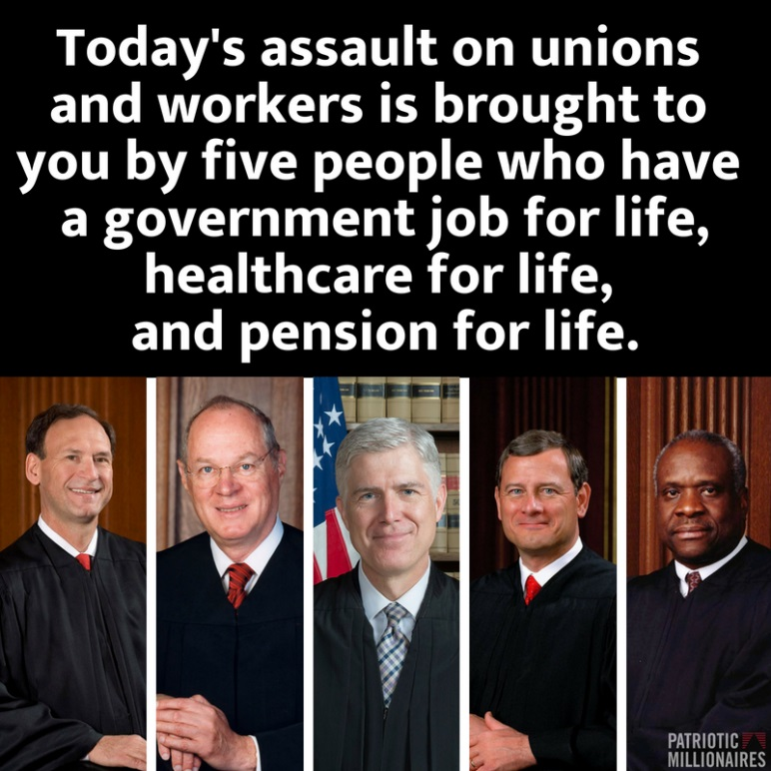
For the 5-4 majority in the Janus decision, Justice Alito wrote this outrageous statement: “Designating a union as the employees’ exclusive representative substantially restricts the rights of individual employees.” (p. 2) Alito then expanded his attack: “First, agency fees cannot be upheld on the ground that they promote an interest in ‘labor peace.’ The Abood Court’s fears of conflict and disruption if employees were represented by more than one union have proved to be unfounded: Exclusive representation of all the employees in a unit and the exaction of agency fees are not inextricably linked. To the contrary, in the Federal Government and the 28 States with laws prohibiting agency fees, millions of public employees are represented by unions that effectively serve as the exclusive representatives of all the employees. Whatever may have been the case 41 years ago when Abood was decided, it is thus now undeniable that ‘labor peace’ can readily be achieved through less restrictive means than the assessment of agency fees.” (p. 2).
“But we must weigh these disadvantages against the considerable windfall that unions have received under Abood for the past 41 years. It is hard to estimate how many billions of dollars have been taken from nonmembers and transferred to public-sector unions in violation.” (p. 47)
To her credit, in a dissenting opinion in the Janus case, Justice Elena Kagan wrote: “Its decision will have large-scale consequences. Public employee unions will lose a secure source of financial support. State and local governments that thought fair-share provisions furthered their interests will need to find new ways of managing their workforces. Across the country, the relationships of public employees and employers will alter in both predictable and wholly unexpected ways.” (Dissent- p.2)
The future will determine whether they are correct.
Another destructive legal challenge to unionism is proceeding through the courts as another California public school teacher (not Rebecca Friedrichs) named Robin Yohn claims that the “opt-out” procedures of the California Teachers Union, and also a violation of the First Amendment rights.
“Yohn’s case raises a second issue, one that will likely still be on the table even if the Supreme Court sides with Janus and overturns mandatory dues, as it’s expected to do. The California teachers argue that the current opt-out process for those who don’t want to pay dues is overly burdensome and also violates the Constitution. Instead, they maintain, educators who want to join should have to affirmatively opt into the union. Teachers who don’t know about, or can’t follow, the opt-out process are also being forced to subsidize speech they don’t support, said Terry Pell, president of the Center for Individual Rights, which brought Yohn’s case. The libertarian nonprofit law firm also represented California teacher Rebecca Friedrichs in her 2016 case challenging union dues. ’The opt-in/opt-out issue is just as much a First Amendment issue as the compulsory dues issue,’ he said. ‘They both go to unconstitutional burdens that the state is putting on speech.’”
Before the Janus decision, and as another illustration of the shrewd thinking in the anti-union movement, a diabolical strategy was developed by Governor Paul LePage of Maine—divide and conquer-- to effectively split the membership of the two largest state unions, eventually persuading the members to “voluntarily” give up the agency fee clauses in their contracts.
As a kind of role model for Donald Trump, LePage has been described by various observers as “a crude buffoon,” “the most ignorant, angry, racist, and buffoonish leader in America,” and as “a terrible governor, a worse person, and he says something dumb nearly every single week. He’s a never-ending source of stupidity.” He told the Portland NAACP to “kiss my ass” when the civil rights group invited him to speak soon after his election in 2010 and demanded the removal of murals depicting Francis Perkins, the famous Secretary of Labor who had family roots in Maine. “The mural “sends a message that we’re one-sided, and I don’t want to send that message,” said LePage.
LePage proclaimed his support for open shop legislation after his election in 2010 but was unable to get it passed in 2013. In 2015, the legislature once again voted against making Maine the 29th open shop state.
In the 2017 negotiations, LePage’s administration proposed a choice to the Maine State Employees Association, Local 1989, with about 9,000 members, and to the AFSCME Council, with 900 corrections and mental health workers: get a two-year contract with 6 percent raises and eliminate agency fee clauses or keep the clauses and get a 1 percent raise. “MSEA-SEIU Local 1989 contract negotiators accepted the change in support of the pay increase in August, but negotiators for AFSCME rejected the proposal, recommending instead accepting only a 1 percent raise. But the 900 or so members of AFSCME rejected the negotiators’ contract and voted to ratify LePage’s offer, giving them the 6 percent wage increase while eliminating the mandatory fees for nonunion members.” While the president of the SEIU council proclaimed that “the union has “emerged stronger and more united” as a result,” LePage clearly outorganized the officers of both unions.
The issue predictably raised on social media the discussion of the value of unions, with comments on the news article running from
- “As a dues-paying member of MSEA Local 1989, headline should be revised to read: ‘State workers get greedy and lose sight of the bigger picture’” to
- “Umhuh. Lets see...’feed the family’ or ‘feed the union’. Workers chose their families. Correct choice” and
- “It's nice to see the Forced Unionism fees will no longer be required as a condition for those folks to keep their jobs” and
- “MSEA Local 1989 Union leadership - six figure salaries. Yikes. The salaried union organizers make more than who they represent. I'm sure they want mandatory dues so THEY get a paycheck” and ““Free riders? I'm not a free rider, I DON'T WANT A RIDE!! I can take care of myself thank you. If I don't do my job well, I will be fired, as it should be. I don't need a Union FORCING me to pay them for NOTHING! Jeez dude, you don't get it do you? The union makes nothing possible for me, I'm not a sheep” and finally,
- “Now, every single state employee should join the union. Remember as Labor Day approaches the 8 hour work day, the 40 hour work week, child labor laws, overtime pay, minimum wage, call-back rules, hazardous duty pay...you enjoy all because union workers fought and died for your rights.”
“Ramona Welton, the president of MSEA-SEIU Local 1989, said the concessions on mandatory fees were necessary to get better wages for workers,” and claimed “she believed the union has “emerged stronger and more united” but the Director of MSEA, Rod Hiltz, resigned, explaining that 7 staff reps (approximately ¼ of total staff) were slated to be laid off, but with his resignation and resultant salary savings, there would be fewer losing their jobs.
Complicating the situation even more was a report from a Maine staff rep that “during negotiations two years before, LePage made the same offer. The negotiating team, made of reps from each of the 4 units, voted not to inform the members of that offer so 3 units voted to accept the alternate offer of 1% per year, unaware of the 3% per year with loss of fair share offer. However, 1 unit, Operations & Maintenance, learned of the 3%...offer & so the members voted to reject the 1%. . . offer.”

* * * * * * * * * * * * * * * * *
While the Janus decision is limited to public sector workers, in the private sector, the attacks on mandatory union membership have been going on for hundreds of years. A “union security,” or “union shop” clause required any new hire to become a member of the union after a specified period of time.
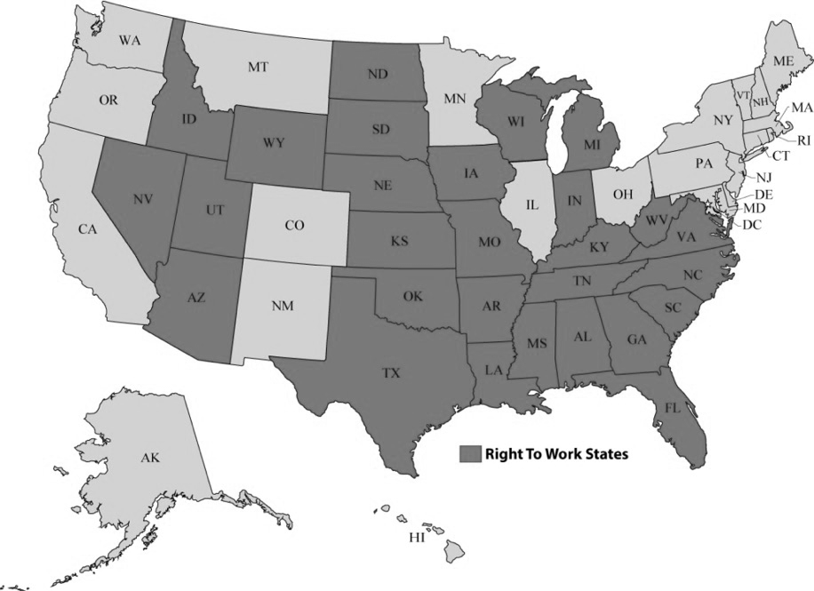
One attack on the union shop started after World War II with the passage of the Taft-Hartley Act in 1947, reflecting a new and aggressive anti-unionism that had been stalled during the war. The law allowed states to individually pass open shop laws—misnamed “Right-to-Work” laws—which explicitly denied a union the right to negotiate a union shop clause. In 1947, there were no open shop states—now there are 28, with more possible—not the direction the arc of history should bend.
In early 2017, Reps. Joe Wilson (S.C.) and Steve King (Iowa) introduced a national Right-to-Work bill, which had the support of President Trump. “’The president believes in right to work. He wants to give workers and companies the flexibility to do what’s in the best interest for job creators,’ White House Press Secretary Sean Spicer said during the Feb. 3 daily news conference. ‘Obviously the vice president has been a champion of this as well.’”
Even in states where unions could negotiate union shop clauses, however, there were legal challenges that cut into this requirement. In the NLRB v General Motors case (1963) the US Supreme Court ruled that a union could negotiate an agency fee clause, requiring that a worker covered by the union contract who did not wish to become a member pay FULL dues and initiation fees. As a result, workers could continue working under the union contract but were not “members.”
A second attack came in 1988, when a Supreme Court decision in Communications Workers v Beck ruled that unions “are authorized by statute to collect from non-members only those fees and dues necessary to perform its duties as a collective bargaining representative.” Union staff then had to keep track of all expenditures—of time and of money—to satisfy the requirement that money was spent on collective bargaining. The workers were considered “financial core” payers, and not union members. Over the years, different decisions have shifted the financial requirement—is new organizing a “collective bargaining” benefit? –but the ability of a worker to continue under a union contract without becoming a member or paying full dues was established.

* * * * * * * * * * * * * * * * * *
A major political controversy involves the financial stability of government, and who is responsible for growing deficits at every level. Working class advocates claim the reduction in taxes on the wealthy have cut revenues while conservatives blame public employees—stereotyped as overpaid, lazy and incompetent—and workers who collect public benefits, like Medicaid or food stamps and who live in publicly subsidized housing.
One whole element of the Janus case is a basic attack, not just on public sector unions, but on public ownership, by claiming that the unions conspire run up huge public deficits. “Justice Anthony Kennedy suggested that unions were working together with public officials to produce "massive government" and higher taxes. Doesn't it blink reality to deny that that's what's happening here?" Kennedy asked. One right-wing group stated in 2013: “Public-sector unions took forced dues from more than 250,000 public employees in 2013, siphoning away taxpayer money to support the unions’ shared goal of bigger government.”
Wisconsin Governor Scott Walker set the pattern for governors in 2011 when he covered his anti-unionism in a state budget he called “The Budget Repair Bill,” as if he were protecting all workers in the state by devastating public sector unions. ““We can no longer live in a society where the public employees are the haves and taxpayers who foot the bills are the have-nots,” Walker proclaimed in his 2011 inaugural address.
This attack was echoed by Justice Samuel Alito in the Janus decision. “Illinois, like some other States and a number of counties and cities around the country, suffers from severe budget problems. As of 2013, Illinois had nearly $160 billion in unfunded pension and retiree healthcare liabilities. By 2017, that number had only grown, and the State was grappling with $15 billion in unpaid bills. We are told that a ‘quarter of the budget is now devoted to paying down’ those liabilities. These problems and others led Moody’s and S&P to downgrade Illinois’ credit rating to “one step above junk”— the “lowest ranking on record for a U.S. state.” (Janus decision. pp 27-28)
Public-spirited citizen that he is, Mark Janus also presented himself as a defender of fiscal responsibility. In an Op Ed in The Washington Post, Janus proclaimed: “My home state of Illinois is in financial free fall. The state has billions of dollars in unpaid bills, has unbalanced budgets and is bleeding people and money.” Janus makes the outrageous claim about “the incredibly generous, taxpayer-funded pension offered to state workers — an average of $1.6 million per state employee, according to a report from the Illinois Policy Institute.”
“I would gladly forgo my annual raise because it’s more important to me that the state get its financial house in order. I would happily have my pension converted into a 401(k), instead of piling more obligation onto the bankrupt pension fund. But I haven’t had a choice about either of these, and I have been forced to pay for a private organization that I don’t want to be a member of to negotiate for things I don’t believe in.”
In particular, Janus “believes that the Union’s ‘behavior in bargaining does not appreciate the current fiscal crises in Illinois.’” This opposition emphasizes both the anti-unionism of the campaign but also the attacks on public facilities—schools, hospitals, medical programs.
In the Janus decision, Justice Alito noted the union’s position. “But when the State offered cost-saving proposals on these issues, the Union countered with very different suggestions. Among other things, it advocated wage and tax increases, cutting spending ‘to Wall Street financial institutions,’ and reforms to Illinois’ pension and tax systems (such as closing ‘corporate tax loopholes,’ ‘[e]xpanding the base of the state sales tax,’ and ‘allowing an income tax that is adjusted in accordance with ability to pay’).” (p. 29)
Uh, so deficit spending or public policy is a First Amendment issue?

* * * * * * * * * * * * * * * * * *
It is also urgent to understand that the anti-union campaign was well-planned and is not finished simply because of the Supreme Court decision. The legal challenge is simply one part of a comprehensive anti-union organizing campaign. As soon as the decision was posted, a sophisticated web site called My Pay My Say (https://www.mypaymysay.com/) appeared, sponsored by the Mackinac Center for Public Policy, founded by the DeVos family which made its money from Amway. The site has links to every state with detailed instructions on withdrawing as an agency fee payer (or even as a union member), including a dropdown menu for each state listing its public sector unions. The Center boasts on its web page that it has been working for 25 years to get the state of Michigan to pass an open shop law. “Type right-to-work into our website’s search engine and it will return 514 articles, blog posts, special essays and news coverage generated by Mackinac Center analysts,” states a column by Michael D. LaFaive.
As part of its organizing campaign, the Center has a note at the bottom of each page: “I allow MyPayMySay.com to store this information in order to help public employees exercise their rights when it comes to union dues, fees and representation. It may be used to contact or follow up with you.”
“The Mackinac Center is planning to spend $10 million this year and $40 million to $50 million over the next two or three years on a “national awareness campaign.” The organization has already opened a national call center, staffed around the clock by 20 trained representatives, to help public employees opt out. It will also fund canvasses and literature campaigns across the country, said Lindsay Killen, the vice president for strategic outreach and communications at the Mackinac Center.”
The state of Illinois immediately posted a web page called Change Your Membership Status, proclaiming “As a result, effective immediately, the State will stop deducting "fair share" fees from the paychecks of State employees who are not union members. Going forward, State workers may choose to either be members of a union or non-members – there will be no ‘fair share’ designation.”
The page contained detailed instructions on how to withdraw from a union, and the most blatant appeal, right out of Marty Levitt’s playbook: “Unions are still obligated to fairly represent all employees in collective bargaining, whether they are members of the union or not. Of course, your decision to join or withdraw from the union will not impact your job protections with the State. You will NOT lose your employment benefits if you opt-out of the union. Illinois statute requires the State to provide healthcare benefits, retirement benefits and many other employment benefits. They do not depend on union membership or collective bargaining. In addition, even if you opt-out of the union, you still receive the same employment benefits as union members.”
Other states also immediately posted information about the Janus decision and about the procedure for agency fee payers to withdraw completely from a union. In Oregon, a web site called OptOutAFSCME, has forms to withdraw and another series of anti-union presentations, like:
Will the union stop helping me with workplace issues?
The union has been recognized by the state as the “exclusive representative” of all members of the bargaining unit, whether formal union members or not. In return for the monopoly on this particular service, unions have a corresponding legal duty to provide fair representation.
These web sites are part of a sophisticated and comprehensive anti-union campaign, supported by the Freedom Foundation, a creation of the Koch Brothers, to devastate public sector unions on the west coast. The Freedom Foundation
“will deploy 80 people to a trio of West Coast union bastions: California, Oregon and its home state of Washington. The canvassers were hired in March and trained this month, according to internal documents reviewed by Bloomberg News. The goal of the multi-pronged campaign is to shrink union ranks in the three states by 127,000 members—and to offer an example for similar efforts targeting unions around the country. . . . In February, it began acquiring lists of workers and identifying public employees to feature in anti-union videos. This month, it has been assembling materials to provide to sympathetic local-government human resources departments and readying a toll-free call center. . . . the Freedom Foundation reported a 2016 budget of $4 million. Its current assault on unions is modeled on past efforts that targeted home health aides, who in 2014 were given the option of not paying fees, and other government workers, who had a choice of paying full dues or smaller representation fees. Nelsen declined to identify any of its donors, which he said include businesses, foundations and individuals ‘from all different walks of life.’ All donations are “made by those who believe in our mission,” he said. However, tax filings reveal a who’s-who of wealthy conservative groups. Among them are the Sarah Scaife Foundation, backed by the estate of right-wing billionaire Richard Mellon Scaife; Donors Trust, which has gotten millions of dollars from a charity backed by conservative billionaire brothers Charles and David Koch; from the Richard and Helen DeVos Foundation, backed by the family of U.S. Secretary of Education Betsy DeVos; and the State Policy Network, which has received funding from Donors Trust and is chaired by a vice president of the Lynde and Harry Bradley Foundation. . . . According to the group’s documents, targets for its new ‘insurgency’ campaign include corrections officers and teachers, who will be out of school for the summer and thus ‘have no interaction with their union.’ Because the Oregon chapter of the American Federation of State, County and Municipal Employees, or Afscme, has been preparing members by ‘aggressively messaging’ them, the anti-union group’s documents state, taking a more patient, less-aggressive approach with those workers will help to ‘demonize’ the union.”
In another state, “New Choice NY, is now advising union members of their right to stop paying regular dues, as well non-union members who had been forced to cough up so-called ‘agency’ fees.’ ‘Want to exercise your right to stop paying dues? Use this form,’ the group, an affiliate of Americans for Fair Treatment, proclaims on its website in guiding government workers how to quit their unions. Americans for Fair Treatment’s three-member board includes the CEO of the right-leaning Commonwealth Foundation in Pennsylvania, which is backed by donors linked to the anti-union billionaire Koch brothers, The Philadelphia Inquirer reported. New Choice NY spokesman Bob Bellafiore insisted his group is about providing workers ‘factual information’ about their rights, not busting unions.”

“The Buckeye Institute has launched a campaign called “Workers Choose” to let employees know about a Supreme Court decision issued June 27 that its says “recognized the right of public employees to choose whether to financially support their union.” The Institute is described as “a nonpartisan, nonprofit entity based in Columbus, Ohio, which advocates for what it calls free market public policies in the states,“ and immediately filed suit in federal court in St. Paul, MN, in behalf of a professor at St. Cloud State University” over alleged faculty union control of certain committee assignments. In a different attack on unionism, this court case is also challenging the principle of “exclusive representation”—only one union representing the workers at a location or employer.
To extend the campaign, groups like the Freedom Foundation have been using the Freedom of Information Act to get lists of state employees. “The Freedom Foundation described obtaining the contact information of 300,000 public employees in Washington using open records requests as being ‘like a prospector locating a vein of gold.’ The Freedom Foundation claims that its multiyear campaign cost SEIU 925 two-thirds of its members. The union confirms this loss rate but attributes it to a high-attrition workforce, not the opt-out campaign.”

* * * * * * * * * * * * * * * * * *
How are union officers responding?
“When the Janus opinion is issued, some celebrity appeal to rally union support will roll out, [SEIU President Mary Kay] Henry said, from SAG-AFTRA and the NFL players unions to actress Sally Field, who stood on a desk holding a sign simply saying “union” in a powerful iconic scene from her 1979 film, ‘Norma Rae.’”
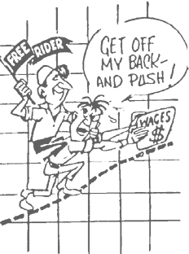
While the anti-union forces moved rapidly to encourage agency fee payers to drop out, and states like New York announced that it would no longer administer check-off for agency fee payers, the officers of the AFL-CIO could only propose new legislation, called The Public Service Freedom to Negotiate Act of 2018. The legislation is authored by Sen. Mazie Hirono, D-Hawaii, and Rep. Matt Cartwright, D-Pa., and co-sponsored by 31 Senate and 19 House Democrats, including Senate Minority Leader Chuck Schumer, D-N.Y., and House Minority Leader Nancy Pelosi, D-Calif. While Bill Samuel, the Government Affairs Director for the AFL-CIO, sent out a message urging people to sign an electronic petition in support of the bill which, “if passed, would strengthen public employees’ right to join a union and give them access to dispute mechanisms at work,” the proposal was savaged by anti-union political strategists.
“’This bill would force all 50 states to give monopoly bargaining powers to Big Labor, in a gross violation of the rights of public employees and the rights of those states’ policymakers. Monopoly bargaining has been a failure in the private sector, and a disaster in the public sector, for every state that has implemented it,’" said Greg Mourad, vice president of the National Right to Work Committee. "’Now the national Democrats want to force it on the rest of the states as well. It’s an obvious payback to the union bosses who spend $2 billion every election cycle to help them get elected.’"
So now we know all of the things the bosses are doing to us. What do we do?
“The SEIU has its ‘Together #WeRise drive;’ ‘AFSCME Strong in Illinois’ was launched last August. The unions have been using all their tools: direct personal contact, organizer training, videos, fact sheets, ads, townhalls, flyers and direct mail. AFSCME Council 31, SEIU Local 73 and the Chicago Teachers Union start out with most of their eligible workers already dues-paying union members. ‘In a very real sense, we are taking a very negative situation and remaking it as a way to deepen and strengthen our union and grow even stronger,’ [Anders] Lindall said. AFSCME Council 31 represents more than 70,000 Illinois workers and 90 percent are dues-paying members, Lindall said. SEIU Local 73 with about 29,000 members in Illinois and northwest Indiana grew by about 800 members between August 2017 and March 2018, according to spokesman Jesus Canchola Sanchez. The Chicago Teachers Union 23,681 members take in 98 percent of eligible Chicago Public Schools workers.”
One failure of the union movement since World War II has been the inability to organize in many states. More than half (7.9 million) of the 15.7 million union members in the U.S. lived in just six states (California, New York, Illinois, Michigan, Ohio, and New Jersey), and even where union membership—on paper—is high, the union movement has been beaten badly politically. In both Illinois and Michigan, for example, openly anti-union governors were elected—and re-elected in Michigan-- so agency fees were either challenged, as in Illinois, or cancelled, as in Michigan which became an open shop state in 2012. As part of the anti-union campaigns that were unfortunately so successful, unions in Wisconsin, Michigan, Indiana, and Iowa lost agency fees after 2010.

While there has been some hot rhetoric about the decision--““The cork is out of the bottle. This is an orchestrated attack on the labor movement. If they think they’re going to dupe or trick hardworking union members, they have another think coming” proclaimed Mario Cilento, President of the New York State AFL-CIO—it will only be blocked only if union members at every level—officers, staff, members, retirees--change their attitudes and strategies or else we will be shown to be, by Einstein’s definition, insane.
The membership numbers and political defeats demonstrate that the union movement in the US must totally change the way it functions. Suggested changes for the basic functions of the unions—grievances, contract negotiations, organizing and political action and their financial priority—are covered in detail in the two books, Closing Up the Open Shop: A Guide to Internal Organizing and Don’t Trump On Us: Making Our Unions Great Again.
One unique observation came in Hawai’i, where the president of the Grassroots Institute stated:
“Already, the Hawaii Legislature is pondering how to respond if the Supreme Court rules in favor of Janus. But the people who are wrapped up in the political implications of the Janus case are ignoring an opportunity that may actually benefit our public sector unions. Though unions are treating Janus as though it is a threat to their existence, it's possible that this case could be an opportunity for our state employee unions to modernize and become more responsive to their members. If the members consider their unions to be valuable voices for their interests, they will gladly support them, even if the dues no longer are mandatory. If they choose not to pay the dues, the unions will know that they need to change their ways to keep their members satisfied. In a sense, Janus would simply give the unions a taste of the free market. It's easy to see why they would prefer the status quo, but a little change doesn't have to be a bad thing.”
There are examples of the workers movement becoming powerful and exciting again. The surge of public sector organizing by “unhappy” teachers in the spring, with walkouts in West Virginia, Oklahoma, Colorado, Arizona and Kentucky show the enormous anger of public sector workers. The walkout also illustrates the complex position of unions because these are states where Janus will have no impact because they do not have public sector bargaining laws.
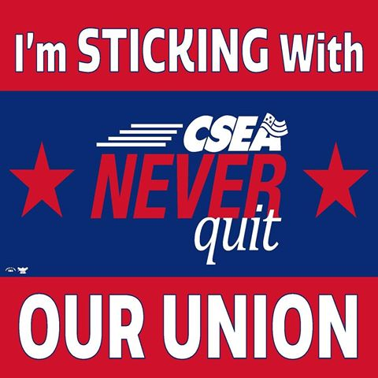
From an organizing perspective, the numbers were astonishing and encouraging as the teacher walkouts spread across the country. In the open shop state of Arizona, for example, there are 90,000 certified teachers but only about 20,000 (22%) were members of the Arizona Education Association. When it came time to vote on a strike, however, 57,000 (63%) filled out a ballot and a huge majority of the teachers risked discipline by walking out of their schools. With some strong activity, participation in the union tripled! Build it and they will come.
It is still to be determined whether the teachers’ campaign will become an expanded union movement or if it will become, like the Occupy Movement, a vivid and exciting moment with no lasting effects. For 2018, however,
“Nearly 300 members of the American Federation of Teachers union are running for political office this year, more than double the number in each of the years 2012 and 2016. The teacher candidacies are part of a rising tide of political activism in 2018, with nearly 800 candidates running in the first round of Oklahoma's primaries, breaking the previous record of 594 set in 2006, and more than 200 filing to run in next month's Arizona primary — more than ran during each of the previous three election cycles. The teacher candidacies suggest that the wave of teacher strikes and protests that began last winter in West Virginia and later spread to Oklahoma, Arizona and elsewhere created a grass-roots political opportunity. . . . Teachers unions, meanwhile, are hedging on their commitment to the Democrats amid the national political circus. Although the Oklahoma Education Association's crop of candidates is overwhelmingly Democratic — just six of 33 candidates are running as Republicans — the OEA hasn't forgotten that its membership is split evenly between Republicans and Democrats, said OEA President Alicia Priest. “We're really pushing 'vote your job,'” Priest said. “Public education is your paycheck and your passion, and you need to vote as though it is. . . . The fallout from the teacher protests is even reaching deep-red Arizona. One hundred fourteen Democrats will compete in the Aug. 28 primary for legislative seats — the most on record, according to the Arizona Democratic Legislative Campaign Committee. Teachers are also running a ballot measure campaign that would tax the highest income earners for an additional $690 million to spend on schools.”
A more instructive, and conflicted, approach to increasing membership was presented by the president of the Baltimore Fraternal Order of Police, Gene Ryan, who not only said that “the majority of officers are union members,” but stressed “In 2016, union members voted unanimously to double their dues in order to keep the union solvent. . .”
The impact is that the money was then used to pay legal expenses for six officers criminally charged in the death of Freddy Gray, a young African-American man whose neck was broken while in a police van. The conduct of police, and their union’s defense of these officers is a controversial union practice, of course, but the lesson is that when the union provides benefits, the workers will join—and will even vote to double their union dues!
How would that pass in your local?
Most importantly, every union member has to support our original slogan ”An injury to one is an injury to all.” In many states, which continue union security, private sector unions have not been involved in the struggle against Janus. They figure “it’s not our fight,” but as the private sector unions learned, to their sorrow in states like Wisconsin and Michigan, attacks on the public-sector unions are simply part of a plan to obliterate all unions.
And then they came for us . . .

David Moberg. “Billionaire Governor Bruce Rauner Declares War on Illinois State Unions Through Executive Order.” In These Times. February 11, 2015.
Bureau of Labor Statistics. “Union Membership.” January 19, 2018.
Nathan Eagle. “Why Union Support Matters in the Hawaii Governor’s Race.” Honolulu Civic Beat. July 11, 2018.
Lorraine Mirabella. “Unions call ruling blow to workers.” The Baltimore Sun. June 28, 2018.
Len Lazerick. “State employee unions will start collecting fees from non-members.” Maryland Reporter. July 5, 2011.
Lynn Sweet. “Unions, anticipating Janus case Supreme Court loss, jump-start recruiting drives.” Chicago Sun-Times. June 28, 2018.
Hawai’i Free Press. July 9, 2018
Stewart Yurton. “Hawaii Economists: Public Employee Union Membership Is Bound To Drop.” Honolulu Civil Beat. June 27, 2018.
Moshe Z. Marvit. “For 60 Years, This Powerful Conservative Group Has Worked to Crush Labor.” The Nation. July 5, 2018
Cynthia Estlund and William E. Forbath. “The War on Workers.” New York Times. July 2, 2014.
“After Janus, Another Key Lawsuit Targeting Unions: How California’s Yohn Case Targets Opt-Out Rules.” T74. June 29, 2018.
Scott Thistle. “State workers drop mandatory union fees in favor of more pay.” Portland Press Herald. August 31, 2017
Steve Mistler. “Union Director Resigns, A Day After Maine State Employees Accept New Contract.” Maine Public Radio.
Tyrone Richardson and Ben Penn. “Trump Administration Puts Support Behind Right-to-Work Laws.” Bloomberg Law. February 7, 2017.
Mike Janus. “Why I took my case over forced union dues to the Supreme Court.” Washington Post. July 1, 2018.
Erica Green. “Teachers Unions Scramble to Save Themselves After Supreme Court’s Blow.” New York Times. July 14, 2018
https://www2.illinois.gov/sites/TeamIllinois/LaborRelations/Pages/Change-Union-Membership-Status.aspx
https://www.optouttoday.com/afscme-75-state-employees
Josh Edelson. “Koch Brothers-Linked Group Declares New War on Unions.” Bloomberg. June 27, 2018.
Carl Campanile. “Group wants to teach workers how to stop paying union dues.” New York Post. July 5, 2018
Dan Browning. “St. Cloud State professor alleges forced union representation violates her rights.” Minneapolis Star-Tribune. July 6, 2018.
Chris Brooks. “How Corporations Plan To Use Janus To Turn Workers Against Their Own Unions.” In These Times. July-August, 2018.
Lynn Sweet. “Unions, anticipating Janus case Supreme Court loss, jump-start recruiting drives.” Chicago Sun-Times. June 28, 2018.
Sean Higgins. “Democrats introduce bill to strip workers of rights won under Supreme Court union ruling.” Washington Examiner. June 28, 2018.
Lynn Sweet. “Unions, anticipating Janus case Supreme Court loss, jump-start recruiting drives.” Chicago Sun-Times. June 28, 2018.
Keli'i Akina. “Hawaii unions need not fear Janus case.” February 2, 2018.
Ian Jullgren. “‘Educator spring’ spawns wave of teacher candidates.” Politico. July 4, 2018.
Lorraine Mirabella. “Unions call ruling blow to workers.” The Baltimore Sun. June 28, 2018.

