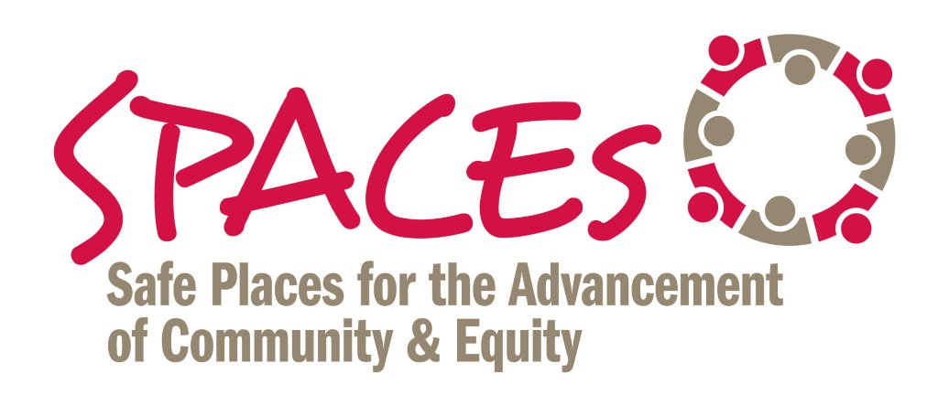
8 STRATEGIES TO
REDUCE/INTERRUPT BIAS

STRATEGY # 1 – Increase Your Awareness

- Take the Implicit Association Test (IAT) at www.withinourlifetime.net OR www.implicit.harvard.edu.

STRATEGY # 2 – Stereotype Replacement – a) recognize when you’re having a stereotypic thought (or when you observe stereotypic portrayals in society; b) identify the factors behind the thought/portrayal; c) replace the stereotype with a non-stereotypic response.

- Recognize when stereotypes are activated: What are the feelings – physiological signs – that you have when you spend time with and/or around people with whom you have “chemistry;” people with whom you “click?” What are the feelings when you’re with and/or around people who are the opposite?

STRATEGY # 3 – Counter-Stereotypic Imaging – imagine in detail a person who counters the stereotype. Alternatively, consider using photos or images to counter existing stereotypes.

- Who’s a person in your work and/or personal life that represents the opposite of the stereotype? What’s the person’s name? What are three characteristics/qualities about the person that counter the stereotype about their group?

- What pictures, photos, symbols can you hang on the wall in the common space and/or program space to counter negative stereotypes about the communities you serve and/or other marginalized groups?

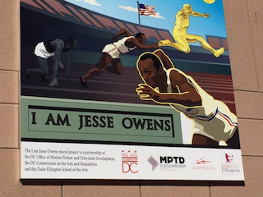

STRATEGY # 4 – Practice Individuation – do regular, in-person, one-on-one meetings with people who: a) you are prone to be biased against and/or; b) who have a lived experience different than your own. The goal is to use individual characteristics (versus generalizations) to inform our judgment.

- List 3 to 5 people who are (or you perceive to be) “different” from you with respect to race, ethnicity, culture, lived experience, etc. Conduct a 30 to 60 minute, in-person meeting with each person.

- Example -- AFSCME Strong campaign – training 5% of its members to engage another 80% “one conversation at a time.”

STRATEGY # 5 -- Practice Perspective Taking – find creative – and respectful -- ways to experience what it’s like to walk in the shoes of a member of a stereotyped or marginalized group.

- Example -- Staff of a city-wide organization that works with homeless families deciding to spend a night living on the “streets” to better understand what it’s like to be homeless;

- Example -- Former Newark Mayor Cory Booker living on food stamps for a week.

STRATEGY # 6 -- Do Inter-group Work – Create and/or join a dialogue group; organize a “brown bag” series; ultimately, the goal is to create opportunities for diverse groups of people to engage in positive contact over an extended period of time.

- Example -- National Park Service (NPS) Allies for Inclusion Program; training NPS staff to be dialogue facilitators; using 60-90 minute monthly "brown bags" as the strategy.

STRATEGY # 7 – IMPROVE DECISION-MAKING. Improve decision-making by slowing down and removing discretion and ambiguity from decision-making.

Example -- Courts Catalyzing Change “bench card” or checklist for judges. See excerpt below:

- What assumptions have I made about the cultural identity, genders, and background of this family?

- What evidence has supported every conclusion I have drawn, and how have I challenged unsupported assumptions?”

STRATEGY # 8 -- PRACTICE, PRACTICE, PRACTICE

- Shifting behavior and culture (individual and organization) requires sustained practice, repetition and feedback.

Note – Several of the above strategies are adapted from “Breaking the Bias Habit: A Workshop to Promote Gender Equity” -- Women in Science and Engineering Leadership Institute at University of Wisconsin-Madison

