Goals
- Identify what commonly happens when racism or white privilege are the topics of conversation
- Explore how those common reactions can reinforce white privilege
- Practise
  - approaches that interrupt expressions of white privilege
  - Staying in the moment of discomfort to develop curiosity rather than defensiveness
- Draw out implications for our facilitation of groups

Agenda
The Workshop Demonstration (8:00—9:30 a.m.)
- Welcome & Openings
- Common Reactions & their Impact
- Practise Interruptions

Feedback and Discussion (9:30—10:00 a.m.)
- Implications for Facilitation

A Couple of Working Definitions

Whiteness is a location of structural advantage, of race privilege. Second, it is a ‘standpoint,’ a place from which White people look at ourselves, at others, and at society. Third, ‘Whiteness’ refers to a set of cultural practices that are usually unmarked and unnamed. Theorists use Whiteness to signify a set of locations that are historically, socially, politically and culturally produced and which are intrinsically linked to dynamic relations of domination.
(R. Frankenberg (1993). The Social Construction of Whiteness: White women, race matters. Minneapolis: University of Minnesota Press. P. 1, cited in “White Fragility” by Robin DiAngelo)

White Privilege has been usefully described by Peg MacIntosh as the “invisible knapsack of unearned assets which White people can count on cashing in each day, but about which they are meant to remain oblivious.” These are benefits White people receive in a racist society at the expense of racialized people. Examples include the ability to be unaware of race; the assurance that police will not stop them because of their race; the expectation that they speak for themselves and not their “race”; the assumption that getting hired or promoted was due to their competence and not because of their “race.”
(T. Lopes, B. Thomas (2006) Dancing on Live Embers: Challenging Racism in Organizations. Toronto. BTL Publications.)

What Happens When You Talk about Racism and White Privilege?
Review the following questionnaire. Mark how often, if at all, you have heard each reaction from white people when racism or white privilege is being discussed.
Response | Often | Some-  times | Never
1. I have a close friend who’s Aboriginal so I’m very familiar with this issue.
2. I don’t agree with this “Black Lives Matter” slogan. ALL lives matter!

3. I wasn’t around when slavery and colonialism happened. I’m not a Ku Klux Klan member, so why are you talking to me about being white?
4. I’ve experienced reverse racism when I didn’t get the job at the fire department. I scored higher than the coloured person who got it.
5. How can you say I’ve benefited from racism when I’ve had to work for everything I’ve got?
6. I experience discrimination myself as a woman. I really object to only talking about racism when so many of us experience other forms of oppression.
7. I’m an activist involved in social justice issues. I have devoted my life to that. I’ve taken anti-racism training. Why are you raising this issue?
8. I’m not part of a racial group, but I support Black Lives Matter. I’m glad those guys are taking to the streets.
9. Too many people use racism as a cover up for the fact that they don’t want to work as hard as I do. I’m sick and tired of hearing the race card.
10. I can’t hear you when you’re so angry about this.

11. I’m feeling unsafe in this conversation. Are you accusing me of racism? What is this, a lynch mob?
12. Listen, I’m one of the few white people that would sit and talk to you about this.
13. Okay, so I’m a white person, but why can’t I attend the people of colour caucus? White people don’t have a caucus.
14. I grew up in an all-white neighbourhood so we didn’t have any racism there. It’s the same in my union local – no racism there.
15. Other?
(Developed by Kai Lai, Adriane Paavo, Barb Thomas, based on the article, “White Fragility”, by Robin DiAngelo. International Journal of Critical Pedagogy, Vol 3 (3), (2011), pp. 54-70. DiAngelo conceptualizes these reactions as “the result of the reduced psychosocial stamina that racial insulation inculcates. [She calls] this lack of racial stamina ‘White Fragility’.”)
Getting Called Out: How to Apologize

What is getting “called out?”
- When you say something that upholds the oppression of marginalized groups, and someone tells you so
- When you perpetuate negative stereotypes that have real consequences for marginalized groups, and someone tells you so

Two ways to apologize:

Successful!
- Listen to the other person – they may explain to you what you did wrong, and, how you can change it.
- When talking about your statement, talk about what you did, not what you intended to do
- Acknowledge and take responsibility for what you did wrong
- Avoid using “but” or “if” in your apology. “But” and “if” impose conditions on the apology
- Thank the person for bringing the issue to your attention by calling you out
- Make a commitment to change your behavior, and, change your behaviour

Unsuccessful

Defensive statements at being called out
- “You’re so sensitive!”
- “You’re so emotional!”
- Claiming familiarity with the marginalized group to minimize your verbal oppression of them
  - “My best friend is black!”
  - “My sister is a lesbian!”
- Mitigating your actions by stating your intent of the statement, rather than acknowledging the impact your statement on another person
  - “You know I didn’t mean it that way!”
  - “You know I was just joking!”
Deflective statements at being called out
- “I’m sorry that you were offended.”

Instead of taking responsibility for your actions, you are putting the blame on the other person. It’s their fault that they are offended, rather than you doing something to offend them.
- “I’m sorry if you were offended.”
“If” is irrelevant because the other person is offended. This does not acknowledge what you did wrong, and, why what you did was wrong. You may also mean “If you were offended, then I’m sorry. If you were not offended, then I’m not sorry. It’s up to you”

(Source: “Getting Called Out: How to Apologize”, Chescaleigh, https://www.youtube.com/watch?v=C8xJXKYL8pU)

Other Questions White People Can Ask Ourselves
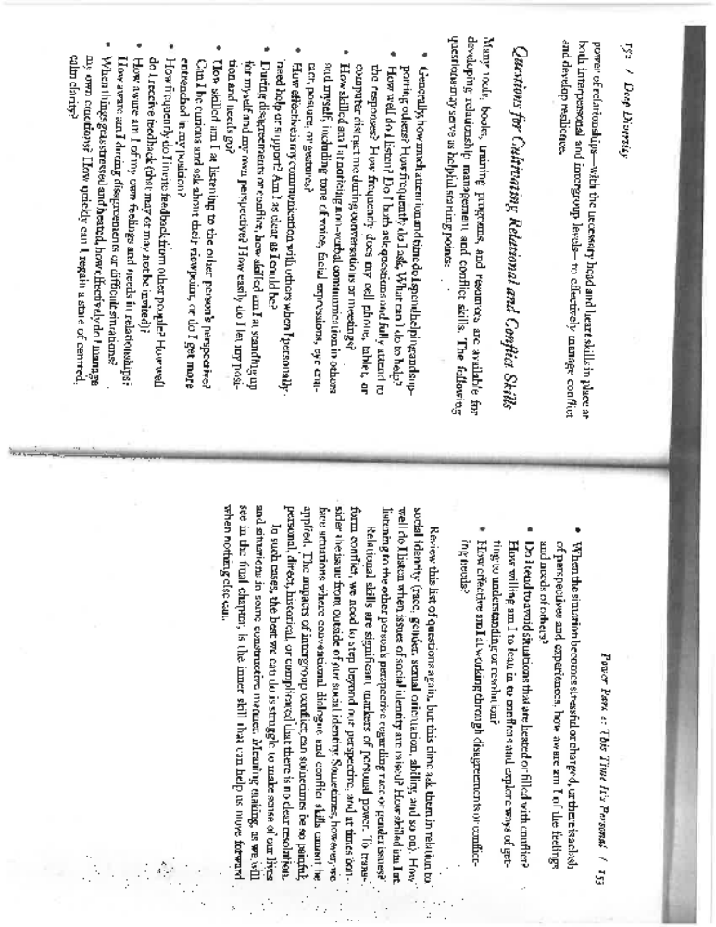
Selected Bibiography
Written Resources
Choudhury, Shakil. (2015). Deep Diversity: Overcoming Us vs. Them. Toronto: Between the Lines.
DiAngelo, Robin. (2011). “White Fragility”. In International Journal of Critical Pedagogy, Vol 3 (3), pp. 54-70.
Jensen, Robert. (2005). The Heart of Whiteness: Confronting Race, Racism, and White Privilege. San Francisco: City Lights.
Kivel, Paul. (2011). Uprooting Racism: How White People Can Work for Racial Justice. 3rd edition. Gabriola Island, BC: New Society Publishers.
Lopes, Tina & Barb Thomas. (2006.) Dancing on Live Embers: Challenging Racism in Organizations. Toronto: Between the Lines.

Videos
“Getting Called Out: How to Apologize”, Chescaleigh, https://www.youtube.com/watch?v=C8xJXKYL8pU
“Reverse Racism”, Aamer Rahman, https://www.youtube.com/watch?v=dw_mRaIHb-M
“Five Things You Have to Stop Saying (about Aboriginal People)”, Wab Kinew, https://www.youtube.com/watch?v=GlkuRCXdu5A
“How to Tell Someone They Sound Racist, Jay Smooth, https://www.youtube.com/watch?v=b0Ti-gkJiXc

What Happens When You Talk about Racism and White Privilege? Part Two
Based on the earlier questionnaire, we’ve added some analysis related to each reaction from white people when racism or white privilege is being discussed.
Possible Response | What’s Going On?
1. I have a close friend who’s Aboriginal so I’m very familiar with this issue. | White people often have a hard time learning and crediting our learning from racialized people. We want to get there first, and to confirm that we’ve already thought about this issue and we can move on. At the same time, we will use an association with a racialized person as a credential that we’re already in-the-know about racism, that we’re a good white person who’s not just surrounded by whites (although we may be). These responses signal an unwillingness to learn, an uneasiness about discussing racism, and a desire to remain on top of the situation, even though we are the learners.
2. I don’t agree with this “Black Lives Matter” slogan. ALL lives matter! | Of course we are all humans, but when applied to racism, this universalism denies the significance of race and the advantages of being white. It assumes that whites and people of colour have the same realities, and that the same doors are open to all.  In addition to claiming that we’re all the same, whites will also claim that we are all unique which also denies white privilege and the significance of race. But being an individual outside of a racial group is a privilege only afforded to white people. People of colour are almost always seen as having a race and being part of a racial group.
3. I wasn’t around when slavery and colonialism happened; I’m not a Klu Klux Klan member, so why are you talking to me about being white? | Whites can recognize Whiteness as something that is significant and operates in society, but also as something that does not relate to our own lives. In other words Whiteness is real but as the individual problem of other “bad” white people, which I’m not.
4. I’ve experienced reverse racism when I didn’t get the job at the fire department. I scored higher than the coloured person who got it. | The claim of individual victimization and the accommodation of it, compounds the unacknowledged privilege. We may or may not have been treated unfairly, but claiming it at this moment shifts the conversation from systemic oppression and white privilege to our individual hurt. It allows us to claim the social resources that should go into dealing with racism
5. How can you say I’ve benefited from racism when I’ve had to work for everything I’ve got? | Our society bombards us with positive images of the white self as well as strongly negative images of the racial “other.” This self-image engenders a self-perpetuating sense of entitlement because many whites believe our financial and professional successes are the result of our own efforts, only. This individualism erases history and hides the ways wealth has been distributed and accumulated over generations to benefit whites today. The denial of privilege & racism covers up the connection between the unequal distribution of social resources and unearned white privilege. The continued existence of structural inequality undermines the claim that privilege is simply a product of hard work.
6. I experience discrimination myself as a woman. I really object to only talking about racism when so many of us experience other forms of oppression. | It’s true that oppressions intersect, and that most of us experience some form of oppression, at the same time as we benefit from some form of privilege. But if the subject is about an identity where we experience privilege, the focus is our privilege. Why are we trying to switch the subject away from our privilege to where we experience oppression? How is our concern about the connection between different forms of oppression served by this?
7. I’m an activist involved in social justice issues. I have devoted my whole life to that. I’ve taken anti-racism training. Why are you raising this issue? | Dominance leads to racial arrogance, and in this racial arrogance, whites will debate the knowledge of people who have thought complexly about race. We feel free to dismiss these informed perspectives rather than have the humility to acknowledge they are unfamiliar, reflect on them or seek more information.  This is further complicated for activists whose own self-image as a good person makes them want to distance themselves from any suggestion that they may be implicated in a racist system.
8. I’m not part of a racial group, but I support Black Lives Matter. I’m glad those guys are taking to the streets. | The belief that white people are not part of a racial group but people of colour are, allows white people to see themselves as objective and free from the psychic burden of race in a wholly racialized society. Race and racism are “their” problems not ours.
9.Too many people use racism as a cover up for their own screw-ups. I’m sick and tired of hearing the race card. | Whites don’t have to think about racism or white privilege until someone brings it up, at which point we penalize them, trivialize the issue, accuse them individually (and collectively) of incompetence so our racial comfort will not be unsettled. “The race card” like the term “reverse racism” suggests that racialized people have the power to impose something on white people, that they have a “weapon” white people don’t have. The real “race card” is played by white people who can throw in their cards, go home and refuse to engage in a conversation about racism.
10. I can’t hear you when you’re so angry about this. | Racial arrogance and the need for racial comfort may lead whites to insist that people of colour explain white racism in the “right” way. The right way is generally polite, rational and devoid of any show of emotional upset or anger that is a sane response to oppression. Even if we acknowledge that racism might be happening, we’re most receptive if racism is discussed as residing in individual white people other than ourselves.
11. I’m feeling unsafe in this conversation. Are you accusing me of racism? What is this, a lynch mob? | Whites are almost always racially comfortable, and have not had to build tolerance for racial discomfort. Thus, when racial discomfort arises, whites typically respond as if something is “wrong,” and blame the person or event that triggered the discomfort (usually a person of colour). White insistence on racial comfort ensures that racism will not be faced. We confuse comfort with safety because we don’t ask ourselves what safety means from a position of social dominance, or the impact on people of colour, given our history, for whites to complain about our safety when we are merely talking about racism. But further, when whites use violent language to describe anti-racism endeavours, it taps into an existing discourse about people of colour as dangerous and violent, and trivializes the actual violent history and present faced by racialized people from white people.
12. Listen, I’m one of the few white people that would sit and talk to you about this. | While white superiority surrounds us, it remains unnamed and denied by most whites. This can lead white people to object morally to racism while refusing to acknowledge any complicity or benefit from racism. Whites who position themselves as liberal often opt to protect their moral reputations, rather than recognize or change their participation in systems of inequity and domination. In such a conversation they may seek reassurance that they are an unusual or “better” white person than the average.
13. Okay, so I’m a white person, but why can’t I attend the people of colour caucus? White people don’t have a caucus. | White people have a sense of entitlement to be anywhere and everywhere. In virtually any situation or image deemed valuable in dominant society, whites belong. This sense of racial belonging is largely unconscious. White people choose segregation all the time without acknowledging it. But if racialized people do so, it makes us uneasy because it highlights our whiteness, our dominance, and our lack of awareness about it.
14. I grew up in an all-white neighbourhood so we didn’t have any racism there. It’s the same in my union local – no racism there. | Because white people believe we do not belong to a racial group, only people of colour do, racism is seen to exist only where there are people of colour present. This belief erases the privilege white people have of living in “good” neighbourhoods (usually understood to mean without people of colour). It erases the possibility that the land we live on may have been cleared of Indigenous or racialized people so we could live here. It erases all the unequal distribution of networks that have provided jobs, promotions, resources that might have produced a white workplace or union local.
15. Other?

(Developed by Kai Lai, Adriane Paavo, Barb Thomas, based on the article, “White Fragility”, by Robin DiAngelo. International Journal of Critical Pedagogy, Vol 3 (3), (2011), pp. 54-70. DiAngelo conceptualizes these reactions as “the result of the reduced psychosocial stamina that racial insulation inculcates. [She calls] this lack of racial stamina ‘White Fragility’.”)

